**Name: Huynh Do – Assignment 1**

**Hypothetical Research: The Impact of Maternal Stress Levels During Pregnancy on Birth Defects**

**Objective:**

* To determine whether levels of maternal stress during pregnancy are associated with risk of birth defects.

**Hypothesis:**

* Higher levels of maternal stress during pregnancy are likely causing greater risk of birth defects.

**Study:**

1. **Population**: Pregnant women stratified into groups based on stress levels:
   * *Group A*: Low stress.
   * *Group B*: Moderate stress.
   * *Group C*: High stress (e.g., chronic stress, trauma, or severe anxiety).
2. **Sample size**: 187,390 women equally distributed across the three groups between the year of 2000 and 2010 in 10 states ( details of data can be found from CDC data )
3. **Inclusion participants**
   * Pregnant women with 18-40 of age and willing to participate in regular stress assessments.
4. **Exclusion participants**
   * Women with history of mental health conditions.
   * Women with history of drug, tobacco and alcohol use during pregnancy.
   * Women with existing medical conditions.
5. **Variables:**
   * Independent variables (IV):
     1. **Self-reported stress**: Using validated questionnaires (e.g., Perceived Stress Scale).
     2. **Timing of stress**: The timing is broken into 3 semesters such as: early, mid and late pregnancy.
     3. **Intensity of stress**: Categorized as low, moderate, or high stress based on survey responses.
   * Dependent variables (DV):
     1. **Structural of defects**: Such as heart defects, cleft lip or brain suffer.
     2. **Impairments**: Such as hearing loss or speed delays.
     3. **Level of defects**: Level could be classified as mild, moderate, or severe.
6. **This research is non-experimental research**

**Sampling Strategies and Data Collection:**

1. **Stress measurement**:
   * **Self-reported or conducted by phone interview**: Individual participant will complete validated level of stress in each trimester. For example, using the Perceived Stress Scale (PSS-10) is a 10-item questionnaire originally developed by Cohen is used to assess stress levels in young people and adults aged 12 and above.
   * **Internal stress:** Such as blood pressure, heart rate etc..
   * **Negative life events**: Significant life events (e.g., financial hardship, funeral, relationship issues such as divorce etc...) will be recorded and tracked.
2. **Birth defect screening for outcomes**:
   * Newborns will be examined for any sign of birth defects within the first 48 hours.
   * Birth defects will be categorized by type (e.g., heart defects, neural tube defects, brain suffer) and severity (mild, moderate, and severe).
   * Follow up: Newborns will be followed for up to two years to detect any further defects or developmental issues.

**Level of measurements of variables:**

1. Independent Variable (IV): Maternal stress
   * Categorical: If the stress is measured as low, moderate or high, this will be a natural category.
   * Continuous (interval/ratio): If stress is measured by heart rate, blood pressure, this will be categorized as ratio data.
2. Dependent Variable (DV): Birth Defects
   * Categorical: If birth defects are found/not found (binary result - Y/N) then this will be nominal data.
   * Categorical: If birth defects are determined by type such as heart defect, cleft lip then also will be considered as nominal data.
   * Ordinal: If birth defects are categorized as level such as: Mild(1), Moderate(2) or Severe(3) then this will be considered as ordinal data with ranked data.

**Summary statistics:**

# Stressful Life Events Experienced by Women in the Year Before Their Infants' Births — United States, 2000–2010:

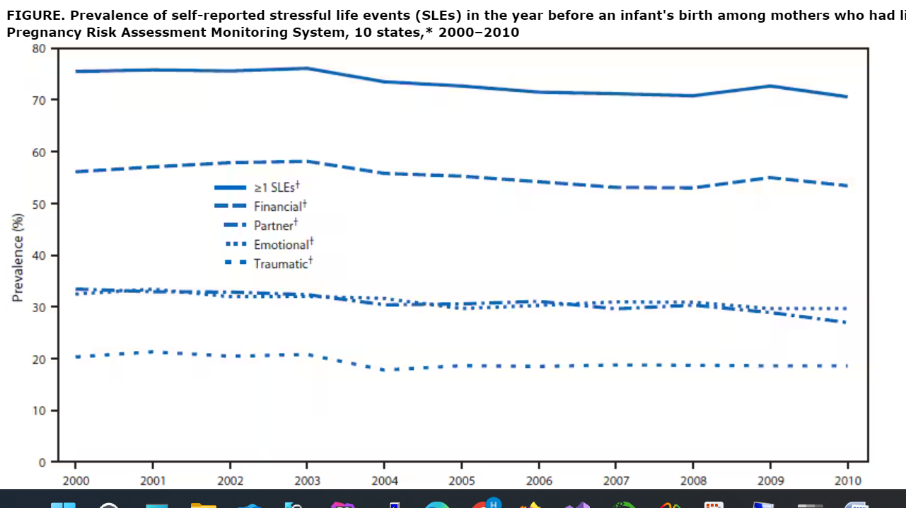

Woman with high level of stress during pregnancy are likely increase the risk of certain birth defects and those including:

* Neural tube defects (NTDs)
* Brain suffer
* Orofacial clefts
* Low birth weight
* Preterm birth
* Peripartum depression

**Cited:**

# Stressful Life Events Experienced by Women in the Year Before Their Infants' Births — United States, 2000–2010:

https://www.cdc.gov/mmwr/preview/mmwrhtml/mm6409a3.htm

National Library of Medicine:

<https://www.ncbi.nlm.nih.gov/pmc/articles/PMC2094125/#:~:text=Increased%20stress%20was%20associated%20with,through%20increased%20production%20of%20corticosteroids>.

https://www.childrensnational.org/about-us/newsroom/2020/when-pregnant-moms-are-stressed-out-babies-brains-suffer