**HUYNH DO**

**Module 4A, Part 2/2**

1. **State the purpose of the exercise**

The purpose of this exercise is to determine whether there is a statistically significant difference in the mean age of individuals who have experienced unemployment in the past ten years compared to those who have not.

1. **State how to calculate the statistical technique**

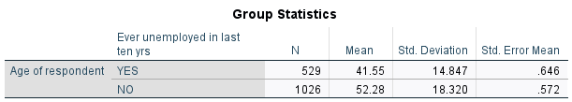

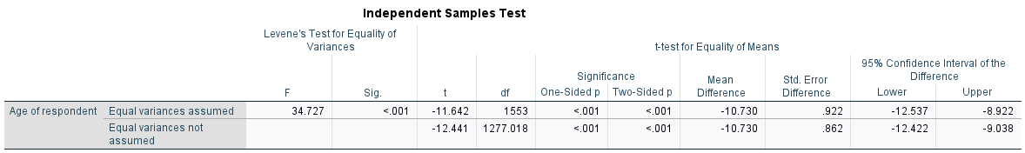

From part 1 and section 1&4, the row "**Equal variances not assumed**" results being used in this case.

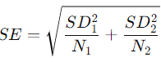 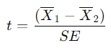 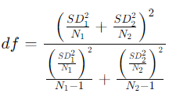

1. **Group 1 ("YES"):** Experienced unemployment
   * N1=529
   * Mean age, X1=41.55
   * Standard deviation, SD1=14.847
2. **Group 2 ("NO"):** Did not experience unemployment
   * N2=1026
   * Mean age, X2=52.28
   * Standard deviation, SD2=18.320

**SE** = **Sqrt(** (14.847­2 /529) + (18.3202/1026)**)** = **Sqrt**( 0.417 + 0.327) = **Sqrt**( 0.744 ) = **0.862**

**t** = (41.55 – 52.28) / 0.862 = -10.73/0.862 = -12.411

**df = (**0.7442 / ( 0.4172/(529-1) + 0.3272/(1026-1) **)** = **1,277.018**

**Lower bound:** -10.73 - (1.96 * 0.862) = -12.422

**Upper bound:**-10.73 + (1.96 * 0.862) = -9.038

1. **Interpret the findings**

The analysis concludes a significant difference in the mean age of people who experienced unemployment in the past ten years compared to those who did not. Especially, young adults are more likely to have experienced unemployment. This suggests age plays a crucial role in the unemployment rate due to possible factors such as less experience (fresh graduation), and career transition. The results point out that unemployment may disproportionately affect younger age groups.