**HUYNH DO**

**Module 5A, Part 1/2**

1. **Specify which variable is the dependent and independent variable:**

Using one-way ANNOVA Test to analyze if there are statistically significant differences in the mean weeks worked across the levels of financial satisfaction.

We now construct these 2 variables:

* **Independent Variable (**Categorical**)** – **SATFIN:** Satisfaction with Financial Situation" with three levels (SATISFIED, MORE OR LESS, NOT AT ALL) serves as the categorical grouping variable.
* **Dependent Variable – WEEKSWRK:** "Weeks Worked Last Year" is a continuous variable that satisfies the requirement for ANOVA test.

1. **Using the variables that you’ve chosen, state the null and alternative hypotheses.**

With the 2 declared above variables, we can construct these 2 Hypotheses:

1. **Null Hypothesis (H₀):**

* There is no difference in mean weeks worked among the satisfaction groups.
* **Mathematical Representation**: H0​: μSATISFIED​ = μMORE OR LESS ​= μNOT AT ALL​

1. **Alternative Hypothesis (H₁):**

* At least one group’s mean "Weeks Worked Last Year" differs from the others.
* **Mathematical Representation**: H1: At least one μ is different

1. **Perform the One-Way ANOVA and interpret the results**

* **Descriptive**

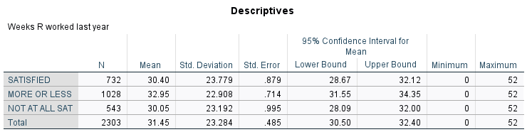

1. **Sample Size (N):**

* There are total of 2,303 people were randomly invited to participate the survey.

1. **Variability:**

* **The standard deviations are similar across groups, ranging from about 22.9 to 23.8 weeks, indicating comparable levels of variability in weeks worked within each satisfaction category.**
* The total sample standard deviation is 23.3, which is very close to individual group, suggesting consistent spread across the data.

1. **Mean Differences:**

* “**MORE OR LESS**” group has the highest mean (32.95 weeks) compared to **SATISFIED** (30.40 weeks) and **NOT AT ALL** (30.05 weeks). This suggests that individuals who are "more or less" satisfied with their financial situation tend to work slightly more weeks, on average, than those who are either "satisfied" or "not at all" satisfied.

1. **Confidence Intervals:**

* **SATISFIED:** mean between 28.67 and 32.12 weeks.
* MORE OR LESS: mean between 31.55 and 34.35 weeks.
* NOT AT ALL: mean between 28.09 and 32.00 weeks.

Since there is overlap among the confidence intervals for each group, there might not be statistically significant differences in the means.

1. **Standard Deviation**

* The standard deviation is around 23 weeks is quite large across the board, and it is relative close to individual group. With such a high standard deviation, the result hints that there’s a broad range of responses within each group, with some people working very few weeks and others working nearly the entire year.

1. **Descriptive Findings:**

In summary, the **Mean Differences, the Confidence Intervals and Variability** together imply that while the average weeks worked might be slightly different by satisfaction level, the overall spread of weeks worked remains fairly consistent regardless of financial satisfaction.

* **One-way ANNOVA Test**

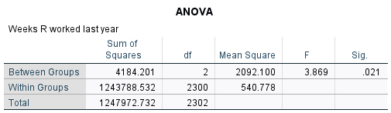

Since the p-value is **0.021** (< 0.05), we **reject** the **null hypothesis (**H0**),** and conclude that there are statistically differences in the mean **Weeks Worked Last Year** among the satisfaction levels (SATISFIED, MORE OR LESS, NOT AT ALL). However, to be able to identify which groups differ, Games-Howell post hoc combines with **Welch’s** ANOVA test would be useful.

* **Homogeneity of Variances Test**

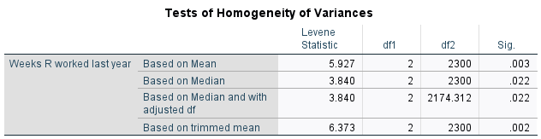

* 1. **Significance (Sig.) Values::**
* Since **Sig** is below 0.05 for all methods, we **reject** the null hypothesis (**(H₀).**This suggests that the assumption of homogeneity of variances is **violated** and alternative Welch’s ANOVA test should be considered for further consideration.
* Since both p-value is **0.021** (< 0.05) and **Sig** is below 0.05, we can safely **reject** the null hypothesis (**(H₀).**
  1. **Welch’s ANOVA** – **An** **Alternative ANOVA test**

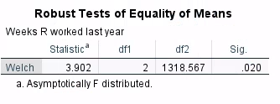

* Statistic: The F statistic is 3.902
* Degrees of Freedom (df1 and df2): The test already adjusted the degrees of freedom for df1 =2 and df2 =1318.567
* Significance (Sig): The significance level (0.020) is below 0.05, indicating a statistically significant difference in the mean "Weeks Worked Last Year" between at least two of the satisfaction levels.
* Since the **Welch’s** ANOVA is **significant**, a **Games-Howell post-hoc** test is needed to identify the specific group differences.

1. **Make sure to assess the test assumption**

To ensure a valid interpretation of one-way ANOVA and subsequent Games-Howell post-hoc test, it’s crucial to assess the key assumptions.

1. **Assumption of Independence**:

Each observation should be independent of others, meaning that feelings about one’s financial status must be influenced by someone else status. The selection of the respondents must be random from the pool. This assumption is likely met.

1. **Assumption of Normality:**

The dependent variable (e.g., "Weeks Worked Last Year") should be approximately normally distributed within each level of the independent variable (e.g., "Satisfaction with Financial Situation"). However, if normality is violated but sample sizes are large, in this case, **N = 2303** generally will tolerate the violations with minor deviation from normality.

1. **Assumption of Homogeneity of Variance**:

* Assumption: The variance of weeks worked should be similar across the satisfaction groups.
* Assessment**:** **p-values** (all tests) < 0.05, indicating that variances are **not equal** across groups.
* Conclusion: This assumption is violated in your dataset. Since ANOVA can be sensitive to unequal variances, this violation justifies using the **Games-Howell post-hoc test.**

1. **If necessary, perform post-hoc tests and interpret the results.**

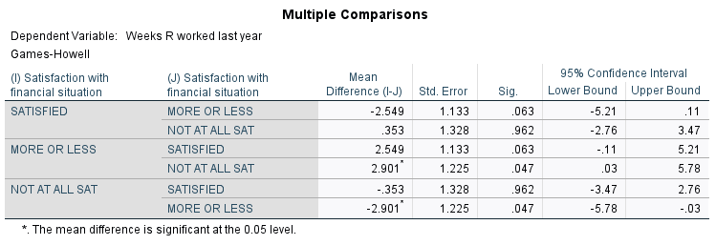

The **Games-Howell** post-hoc test is used to identify which specific groups differ in their means following a significant **ANOVA** result since both **equal variances** and **equal group sizes** are present in this comparison.

From test results table, a standout comparison results between MORE OR LESS and NOT AT ALL SAT satisfaction groups:

1. **Mean Differences**:

The number 2.901 indicates that individual **MORE OR LESS** satisfied group worked an average of 2.901 more weeks compared to those in the **NOT AT ALL SAT** group.

1. **Standard Error**:

The standard error 1.225 gives an estimate of the variability in the mean difference.

1. **p-value (Sig)**:

With a p-value of 0.047, which is less than 0.05, the difference in mean weeks worked between the **MORE OR LESS** and **NOT AT ALL SAT** groups is a statistically moderate difference. This means we can safely say that the observed difference is not by random chance.

1. **95% Confidence Interval**:

The confidence interval indicates that we are 95% confident that the true mean difference in weeks worked between these groups lies between 0.03 and 5.78 weeks. Since the confidence interval does not include 0, thus, we can conclude that there’s moderate statistically difference between the 2 groups **MORE OR LESS** and **NOT AT ALL SAT** groups.

1. **Findings:**

On average, individuals who are moderately satisfied (MORE OR LESS) worked more weeks than those who are not completely satisfied. This suggests that a moderate level of satisfaction with one's financial situation may correlate with a higher number of weeks worked compared to those who are completely dissatisfied.

In other words, on average, people with **more or less satisfaction** with their financial status tend to work **2.9 weeks** more than people who **are not completely** happy with their financial status.

1. **Using an error bar chart, visually display the results of the One-Way ANOVA and explain your findings.**



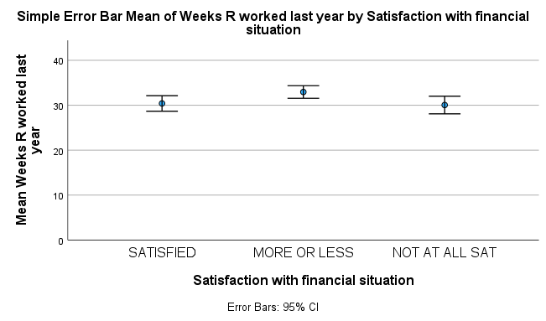

1. **Key Observations:**

The MORE OR LESS group is highest mean weeks worked (**32.95 weeks**) followed by **SATISFIED** (30.40 weeks), and then **NOT AT ALL SAT** (30.05 weeks). However, all 3 means are not really far apart from each other, this indicates that there’s only a moderate (slightly higher) differences in term of financial satisfaction.

1. **Error Bar Mean and Overlap**:

The error bars, which represent the standard error, overlap significantly between the **SATISFIED** and **NOT AT ALL SAT** groups. This overlap suggests that there is likely **no statistically difference** in weeks worked between these two groups.

The interval for **MORE OR LESS** (31.55–34.35) has minimal overlap with **NOT AT ALL SAT** (28.09–32.00), which aligns with the Games-Howell post-hoc test showing a significant difference between these groups.

1. **Findings:**

The minimal overlap between the error bars for **MORE OR LESS** and **NOT AT ALL SAT** suggests a difference in their mean weeks worked, indicating that **moderate satisfaction** with financial situation is associated with **more weeks worked** compared to being **not at all satisfied**. This difference is both visually observable and statistically significant, providing confidence in this conclusion.