**HUYNH DO**

**Module 5A, Part 2/2**

1. **State the purpose of the exercise**

The purpose of this exercise is to determine whether there are significant differences in the average number of weeks worked last year among individuals with varying levels of satisfaction with their financial situation.

By performing a One-Way ANOVA with the additional post-hoc test, the goal is to understand whether the number of weeks worked is the result of fanatical satisfaction or not. This analysis can provide insights into the potential impact of financial satisfaction on work commitment.

1. **State how to calculate the statistical technique**

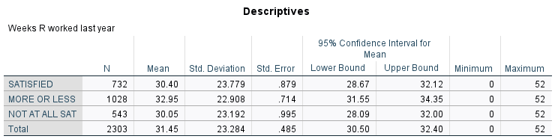

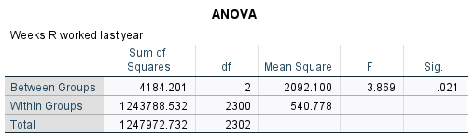

1. **Grand Mean**:

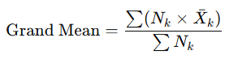

Grand Mean = (732×30.400) + (1028×32.950)+(543×30.050)​ / ( 732 + 1028 + 543 ) = 31.45

1. **Sum of Squares Between Groups** (SSB)

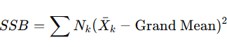

SSB = 4184201

1. **Sum of Squares Within Groups** (SSW)

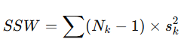

SSW = 12413788.532

1. **Degrees of Freedom**

* **Between Groups:** K−1 = 3−1 = **2**
* **Within Groups = N – K =** 2303−3 **= 2300**

1. **Mean Squares**

* Mean Square Between = SSB/df-between = 4184201 /2 = **2092.100**
* Mean Square Within = SSW/df-within = 12413788.532 / 2300 = **540.778**

1. **F-Statistic**

F= Mean Square Between / Mean Square Within = 2092.100 / 540.778 = **3.869**

1. **Interpret the findings**

The analysis proved that only a moderate satisfaction with financial situation (MORE OR LESS) is associated with a slightly higher number of weeks worked compared to those who are not satisfied at all. In other word, people are willing to work a little bit longer when their financial are not in distress level.

However, the analysis also shows that the relationship between worked between individuals who are SATISFIED and the other satisfaction levels are not clear or meaningful comparison. Although satisfaction impacts work engagement to a small extent, its true impact is limited, suggesting that an additional factor beyond financial satisfaction (**maybe level of stressful**) could change the course of the analysis.