**HUYNH DO**

**Module 5B – Multi ANNOVA, Part 1/2**

1. **Specify which variable is the dependent and independent variable:**

The Module 5A’s analysis concluded that on average, people with more or less satisfaction with their financial status tend to work 2.9 weeks more than people who are not completely happy with their financial status. We will add another control factor **Ever** **Unemployed in the Last 10 Years** to **Satisfaction with Financial Situation** and **Weeks Worked Last Year relationship to see how it might impact the analysis.**

We now construct these variables:

* **Dependent Variable (**Continuous**)** – **WEEKSWRK:** The outcome variable **Weeks Worked Last Year.**
* **Independent Variables (IV)**

1. IV1 - **SATFIN**: This is a **categorical independent variable** representing levels of satisfaction.
2. IV2- **UNEMP**: This is a **binary categorical variable (YES/NO)** that captures whether an individual has experienced unemployment within the last 10 years.
3. **Using the variables that you’ve chosen, state the null and alternative hypotheses.**

With the declared above variables, we can construct these Hypotheses:

1. **Null Hypothesis (H₀):**

* Main Effect of Satisfaction:

**H01**​: There is no difference in the mean **Weeks Worked Last Year** across levels of **Satisfaction with Financial Situation**.

**H01**​: μSatisfied​ = μMore or Less​ = μNot at All Sat​

* Main Effect of Ever Unemployed:

**H02​**: There is a difference in the mean **Weeks Worked Last Year** across levels of **Satisfaction with Financial Situation**.

**H02**​: μUnemployed​ = μNever Unemployed​

* Interaction Effect:

H₀₃: There is no interaction effect between **Satisfaction with Financial Situation** and **Ever Unemployed in the Last 10 Years** on **Weeks Worked Last Year**.

1. **Alternative Hypothesis (H₁):**

* At least one group’s mean from the others.
* **Mathematical Representation**: H1: At least one μ is different

1. **Perform the One-Way ANOVA and interpret the results**

* **Descriptive**

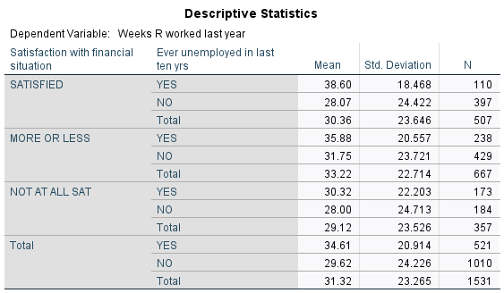

1. **Influence of Satisfaction with Financial Situation:**

* **Moderate Satisfaction (MORE OR LESS):**
* Individuals with “MORE OR LESS” satisfied have the highest average weeks worked (Mean = 33.22).This suggests that those with moderate satisfaction are willing to work longer to improve or stabilize their financial situation.
* **High Satisfaction (SATISFIED):**
* The SATISFIED group worked fewer weeks on average (Mean = 30.36) than those who are moderately satisfied, indicating that very satisfied individuals may feel less pressure or motivation to work additional weeks.
* However, those in the SATISFIED group who have experienced unemployment tend to work substantially more weeks on average than those who haven’t been unemployed.
* **Low Satisfaction (NOT AT ALL SAT):**
* Individuals who are “NOT AT ALL SAT” with their financial situation work the fewest weeks on average (Mean = 29.12), suggesting that financial dissatisfaction might be associated with lower work motivation due to possible lack of motivation, or potential discouragement in maintaining consistent employment.

1. **Effect of Unemployment History:**

* **Those with a History of Unemployment:**

Across all satisfaction levels, individuals who have been unemployed in the past ten years worked more weeks (Mean = 34.61) than those who have never been unemployed (Mean = 29.62). This suggests that those who have experienced unemployment are willing to work longer to make up the loss of financial after returning to work.

* **Those without a History of Unemployment:**

Individuals who have never been unemployed tend to work fewer weeks.

1. **Interaction between Satisfaction and Unemployment History:**

* The relationship between satisfaction and weeks worked is influenced by unemployment history:
* SATISFIED and Unemployed: A history of unemployment could lead highly satisfied individuals to engage more actively in work once re-employed.
* MORE OR LESS and Unemployed (35.88 vs. 31.75): This indicates that moderate satisfaction might drive consistent work engagement regardless of unemployment history.
* NOT AT ALL SAT and Unemployed (30.32 vs. 28.00): This suggests that low satisfaction might limit engagement regardless of employment stability.

1. **Overall Interpretation**

* Satisfaction Level: Moderate satisfaction is associated with the highest average weeks worked, implying that these individuals may be more motivated or compelled to work consistently.
* Unemployment History: Individuals with a history of unemployment tend to work more weeks, possibly regaining financial stability.
* Interaction Effect: Satisfaction and unemployment history interact, with satisfaction level having a stronger effect on weeks worked for those who have experienced unemployment. Those with both high satisfaction and a history of unemployment work the most, possibly reflecting a heightened drive to stabilize financially.
* **Main and Interaction Effects**: Look at the significance of each independent variable in the **Tests of Between-Subjects Effects** table.  
  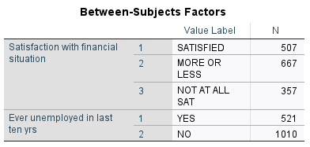

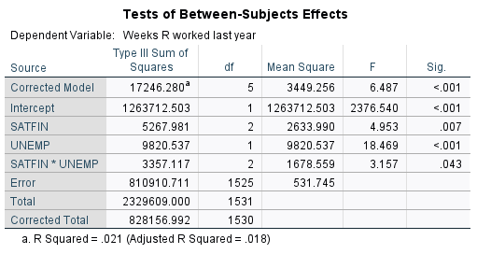

1. **Tests of Between-Subjects Effects**

* The foot note 𝑅2 = 0.021 (2.1%), with an Adjusted 𝑅2 =0.018 indicates that approximately 2.1% of the variance in Weeks Worked Last Year is explained by both satisfaction with financial situation and unemployment status in the last 10 years, along with their interaction.
* The corrected model itself has significant (p < 0.001), meaning that at least one of the effects (main or interaction) contributes significantly to explaining variance in the outcome variable Weeks Worked Last Year.

1. **Main Effects**

* Satisfaction with Financial Situation (**MAIN-SATFIN**):

The p-value for Satisfaction with Financial Situation is 0.007 (F = 4.953), which is statistically significant at the 0.05 level. This suggests that satisfaction with financial moderately influences the average number of weeks worked last year.

* Unemployed in Last 10 Years (**MAIN-UNEMP**):

The p-value for Unemployed in Last 10 Years is < 0.001 (F = 18.469), which is significant. This suggests that having been unemployed in the last 10 years is associated with significant differences in the average number of weeks worked last year, independent of satisfaction level.

1. **Interaction Effect (IN-SATFIN * IN-UNEMP)**

* The interaction term between Satisfaction with Financial Situation and Unemployment status is also significant (p = 0.043). This means that the effect of satisfaction with financial situation on weeks worked differs depending on whether the person was unemployed in the last 10 years.
* Practically, this reveals that a certain level of financial satisfaction may correlate with different patterns of weeks worked based on the person's unemployment history.

1. **Between-Subjects Factors Table**

* **This table shows the distribution across the groups**
* There are 507 individuals who are SATISFIED, 667 who are MORE OR LESS SATISFIED, and 357 who are NOT AT ALL SATISFIED.
* There are 521 individuals who have been unemployed in the last 10 years and 1,010 who have not.
* This balanced distribution allows for a stable analysis of both main effects and the interaction.

1. **Rejected Hypotheses:**
2. Main Effect of Satisfaction with Financial Situation (**MAIN-SATFIN**):

The p-value for this effect is 0.007, which is less than the typical significance level of 0.05. Therefore, **we reject the null hypothesis for Satisfaction** with Financial Situation. This suggests that satisfaction level does significantly affect the number of weeks worked last year.

1. Main Effect of Unemployment Status in the Last 10 Years (**MAIN-UNEMP**)

The p-value for this effect is < 0.001, which is highly significant. Thus, we can **reject the null hypothesis for Unemployment Status**. This indicates that having been unemployed in the last 10 years significantly impacts the number of weeks worked last year.

1. Interaction Effect between Satisfaction with Financial Situation and Unemployment Status (**IN-SATFIN * IN-UNEMP**)

The p-value for the interaction effect is 0.043, which is also less than 0.05 suggesting the effect of satisfaction with financial situation on weeks worked differs depending on whether a person was unemployed in the last 10 years.

Therefore, we can **reject the null hypothesis for the interaction effect**.

1. **Findings:**

* Main Effects: The number of weeks worked last year is influenced indecently by both satisfactions with financial situation and unemployment in the last 10 years.
* Interaction Effect: The effect of financial satisfaction on weeks worked changes depending on the person’s unemployment history, meaning that satisfaction levels do not affect all individuals equally**.**

1. **Make sure to assess the test assumption**
2. Independence Of Observations:

* Assumption: Each observation should be independent of others. This means that each participant’s data is unique to their level of SATFIN and UNEMP, without repeated measurements or paired observations within groups.
* Assessment: Confirm that the study design involves unique participants in each combination of SATFIN and UNEMP levels. This assumption is typically based on study design, and it cannot be tested directly within ANOVA.

1. Normality of Residuals:

* Assumption: The residuals (differences between observed and predicted values) should be approximately normally distributed.

1. Homogeneity of Variance

* Assumption: The variances across groups should be roughly equal.

1. Use post-hoc with LSD option (Least Significant Difference)

* Assumption: Post-hoc with the LSD option is best for identifying specific differences between group means by conducting pairwise comparisons. In this case, it is the best option without adjusting for multiple comparisons; therefore, LSD is appropriate when the assumption of homogeneity of variances is met. A detailed analysis of post-hoc with the post-hoc with LSD option will be analyzed and interpreted in section 5 below.

1. Independence of Observations

* Assumption: Observations should be independent of each other.

1. **If necessary, perform post-hoc tests and interpret the results.**

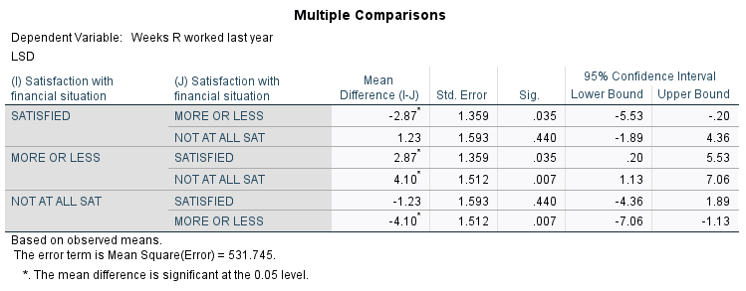

1. **Found Significant** **Paired Comparisons and Interpretation:**
2. **SATISFIED vs. MORE OR LESS (-2.87):**

* Significance (p-value): 0.035 (significant at the 0.05 level)
* Interpretation: People who are SATISFIED worked 2.87 weeks less on average than those who are MORE OR LESS satisfied with their financial situation. Since the p-value is less than 0.05, this difference is statistically significant.

1. **SATISFIED vs. NOT AT ALL SATISFIED (1.23):**

* Significance (p-value): 0.440 (not significant)
* Interpretation: There is no statistically significant difference in the average weeks worked between those who are SATISFIED and those who are NOT AT ALL SATISFIED, as the p-value is greater than 0.05.

1. **MORE OR LESS vs. SATISFIED (2.87):**

* Significance (p-value): 0.035 (significant at the 0.05 level)
* Interpretation: This is the same comparison as SATISFIED vs. MORE OR LESS but in the opposite direction. Those who are MORE OR LESS satisfied worked 2.87 weeks more on average than those who are SATISFIED. This difference is noticeable.

1. **MORE OR LESS vs. NOT AT ALL SATISFIED (4.10):**

* Significance (p-value): 0.007 (significant at the 0.05 level)
* Interpretation: Those who are MORE OR LESS satisfied worked 4.10 weeks more on average than those who are NOT AT ALL SATISFIED. This difference is statistically significant.

1. **Findings**

* "MORE OR LESS satisfied" individuals worked significantly more weeks than both the "SATISFIED" and "NOT AT ALL SATISFIED" groups.
* The "SATISFIED" group did not differ significantly in weeks worked from the "NOT AT ALL SATISFIED" group.
* These results indicate that satisfaction levels do influence the number of weeks worked, particularly for those who are **MORE OR LESS satisfied** compared to the other groups.

1. **Using a line chart, visually display the interaction of the Multi-Way ANOVA and explain your findings.  
     
   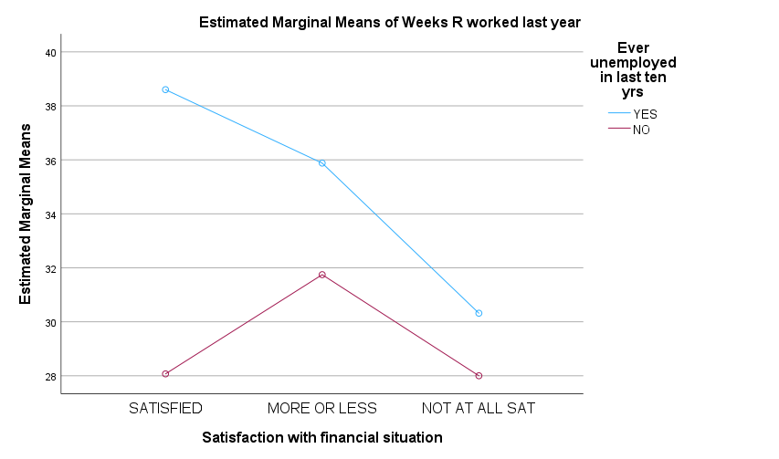**

This interaction plot provides a visual representation of how **Satisfaction with Financial Situation** and **Unemployment Status** together influence **Weeks Worked Last Year**, helping to interpret the nature of the interaction.

1. **Key Observations:**

* For individuals who experienced unemployment (blue line), weeks worked tends to be higher in the SATISFIED and MORE OR LESS groups, with a notable decrease for the NOT AT ALL SAT group.
* For those who were never unemployed (red line) is peaked at MORE OR LESS, there’s a smaller drop in weeks worked in the NOT AT ALL SAT group compared to those who experienced unemployment.

1. **Interpretation:**
2. **More Weeks Worked for those with Unemployment history (YES)**:

* Individuals who have experienced unemployment in the past 10 years (blue line) tend to work more weeks, especially in the SATISFIED and MORE OR LESS satisfaction groups.
* This suggests that, despite periods of unemployment, those with moderate to high satisfaction levels may be more motivated or have greater opportunity to work consistently once re-employed. In another word, after a lengthy out of work period time, people are willing to put more hours to make up the loss due to depleting saving accounts.

1. **Sharp Drop in Weeks Worked for NOT AT ALL SAT (YES)**:

* For those who were unemployed, financial satisfaction seems to play a key role: the NOT AT ALL SAT group shows a marked decrease in weeks worked.
* This indicates that dissatisfaction in financial situation may intensify the impact of unemployment, possibly due to many disappointed or rejected job interview results, leading to discouragement or lack of motivation, therefore fewer weeks worked on average is understandable.

1. **Less Variation for Individuals Without Unemployment History (NO Group):**

* For individuals who were never unemployed (red line) shows consistency across satisfaction levels, with only a slight dip in the NOT AT ALL SAT group.
* This consistency suggests that, for individuals with stable employment histories, satisfaction levels have a less effect on the number of weeks worked.

1. **Interaction Effect:**

* The differences in slopes between the blue and red lines indicate an interaction effect: satisfaction with financial situation influences weeks worked differently depending on unemployment history.
* Specifically, unemployment history amplifies the effect of satisfaction levels on work engagement, with the MORE OR LESS group benefiting the most from having been employed consistently or re-employed after unemployment.

1. **Findings:**

The interaction plot suggests that moderate **satisfaction with financial** situation and a stable **employment history** leads to the highest work motivation. However, on the other end of the aisle, dissatisfaction personal financial causes a negative attitude on those with an unemployment history, leading to greater difficulties in overcoming the dreadful situation and re-establishing consistent work patterns as well. This interaction effect also shows that financial satisfaction and stable employment history contribute to sustained work motivation.