**HUYNH DO**

**Module 5B, Part 2/2**

1. **State the purpose of the exercise**

The purpose of this exercise is to understand how the number of Weeks Worked Last Year is influenced by two factors—Satisfaction with Financial Situation (categorized as SATISFIED, MORE OR LESS, NOT AT ALL) and Unemployment Status in the Last 10 Years (YES or NO) by performing multi-way ANNOVA.

1. **State how to calculate the statistical technique**

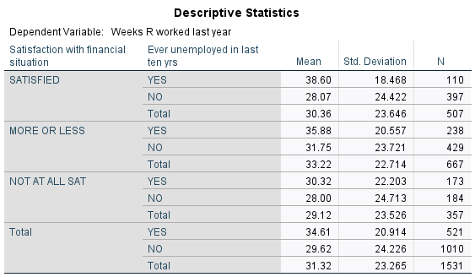

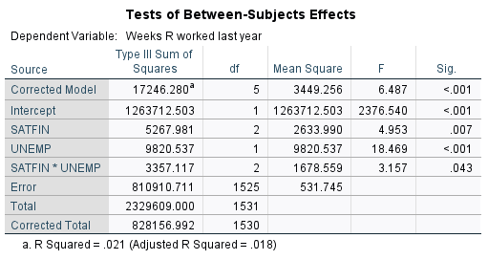

We will calculate **SATISFIED** group form example

1. Grand Mean:

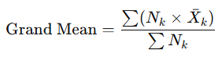

Grand Mean = **31.32**.

1. Calculate the Between-Group Sum of Squares for SATFIN

* SATISFIED
* Sample Size n = **507**
* Deviation for Overall Mean = 30.36 – 31.32 = **-0.96**
* Square of Deviation (-0.96)2 = 0.9216
* Contribution to SS SATFIN: 507 x 09216 = **467.454**
* **MORE OR LESS**:
* Follow the same technique , contribution to SS SATFIN = **2407.870**
* **NOT AT ALL SAT:**
* Follow the same technique , contribution to SS SATFIN = **1728.680**

1. Assemble all numbers together:

* SSSATFIN ​= 467.454+2407.870+1728.680 = **5267.981**
* df SSSATFIN = number of levels of SATFIN−1 = 3−1= **2**
* Mean Square SSSATFIN = SSSATFIN/ d SSSATFIN = 5267.981 /2 = **2633.990**
* F SSSATFIN = SSSATFIN/MS Error = 2633.990 / 531.745 = **4.953**

1. **Findings**

The analysis statistically proves that both **financial satisfaction** and experiencing the **unemployment for the Last 10 years** independently dictate the number of **weeks worked**, and their interaction are categorized in these follow areas:

* Satisfaction with Financial Situation and experiencing Unemployment For The Last 10 Years dictate the Number Of Weeks Worked in the entire year.
* Individuals with different satisfaction levels and unemployment experiences are likely to display distinct patterns in their work behavior, with both factors playing critical roles.
* The interaction effect underscores the complexity of work engagement, as the impact of satisfaction varies depending on an individual’s employment stability.

These results highlight the importance of considering both financial satisfaction and unemployment history when examining workforce participation, as these factors together offer valuable insights into labor patterns and potential areas for support or intervention.