Huynh Do Lab#1:
Objective: To upload data file and to analyze the statistic of the uploaded ceral.csv

1. Import libraries
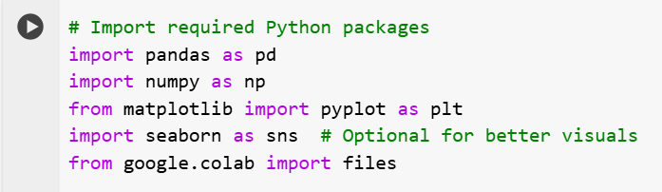
This code above imports several Python libraries commonly used in data analysis.
- import pandas as pd
  - A library for data manipulation and analysis (e.g., working with tables, CSVs, etc.).
- import numpy as np :
  - Support for numerical operations and arrays.
- from matplotlib import pyplot as plt
  - Creating static, interactive, and animated plots.
- import seaborn as sns
  - Imports Seaborn provides prettier and more informative plots.
- from google.colab import files
  - Used in Google Colab to upload/download files from your local system within a Colab notebook.
2. Upload data
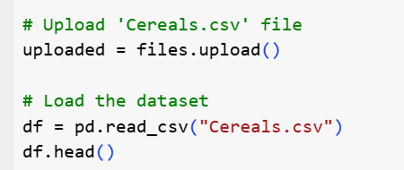
The above screen shot is used to upload and load a CSV file named Cereals.csv into a Pandas Data Frame in a Google Colab environment.
When upload is done:
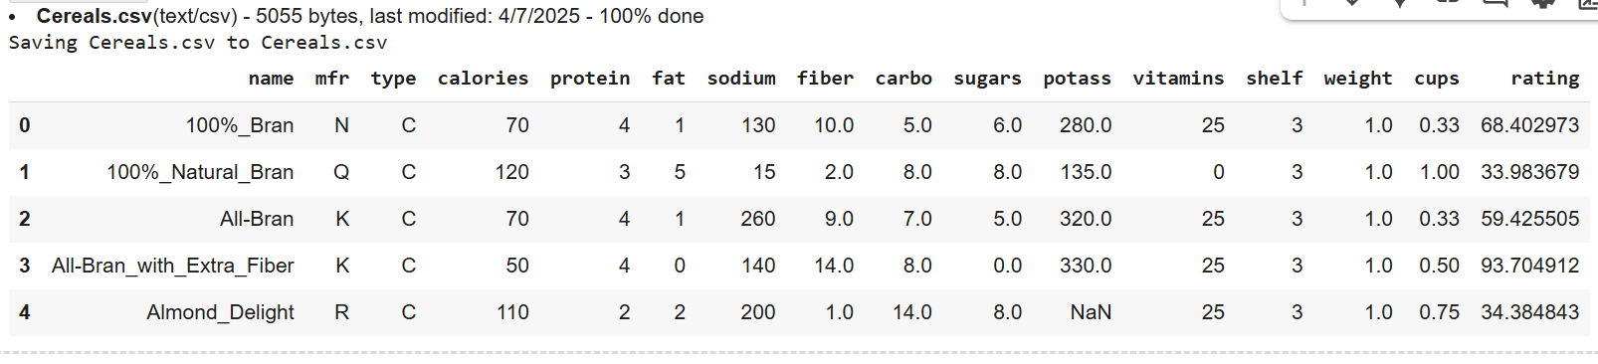
3. Prepare statistic
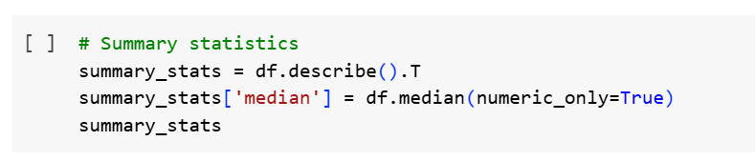
This code generates and displays summary statistics for the numeric columns in a Data Frame (df).

summary_stats = df.describe().T
- df.describe() returns summary statistics (like count, mean, std, min, max, and quartiles) for each numeric column.
- .T transposes the result, so rows become columns and vice versa

summary_stats['median'] = df.median(numeric_only=True)
- Calculates the median for each numeric column in df.
- Adds the median as a new column in the summary stats Data Frame.
- numeric_only=True ensures that only numeric columns are accepted.

summary_stats
- Displays the final summary statistics table, now including the median along with count, mean, std, min, max, and quartiles.
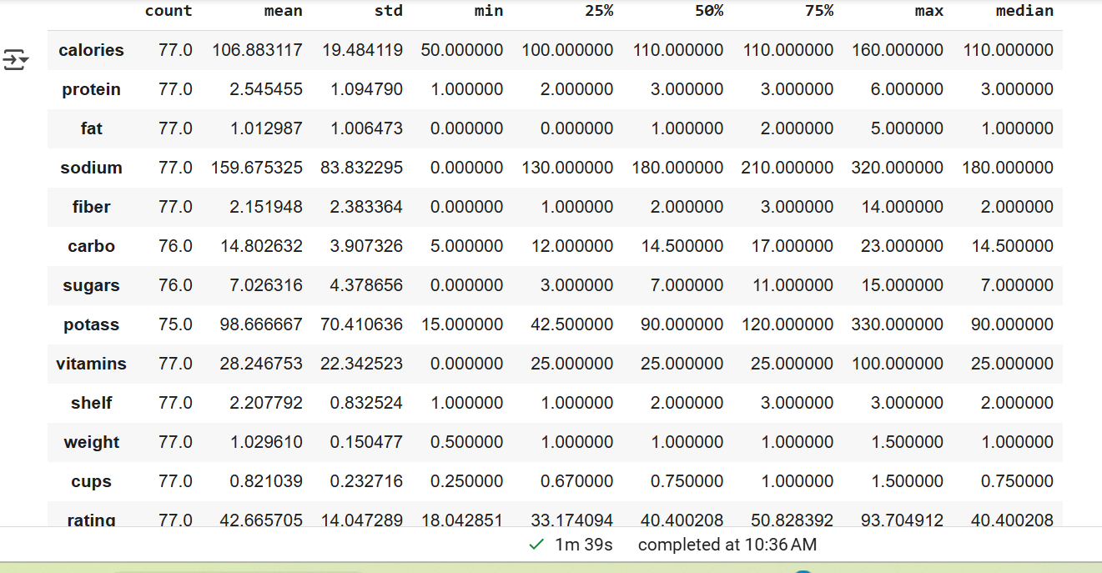
The screen shot above is result of using python to generate statistic data.
4. Prepare Correlation matrix
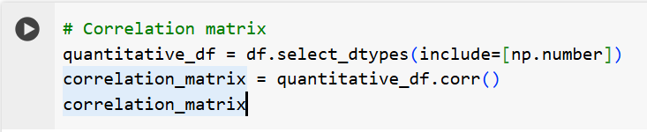
This code is used to compute and display the correlation matrix for the numeric columns.

quantitative_df = df.select_dtypes(include=[np.number])
- This filters the DataFrame df to keep only numeric columns (e.g., integers, floats).

correlation_matrix = quantitative_df.corr()
- Calculates the correlation matrix for the numeric columns.
- The .corr() method computes Pearson correlation coefficients by default.

correlation_matrix
- Displays the correlation matrix.
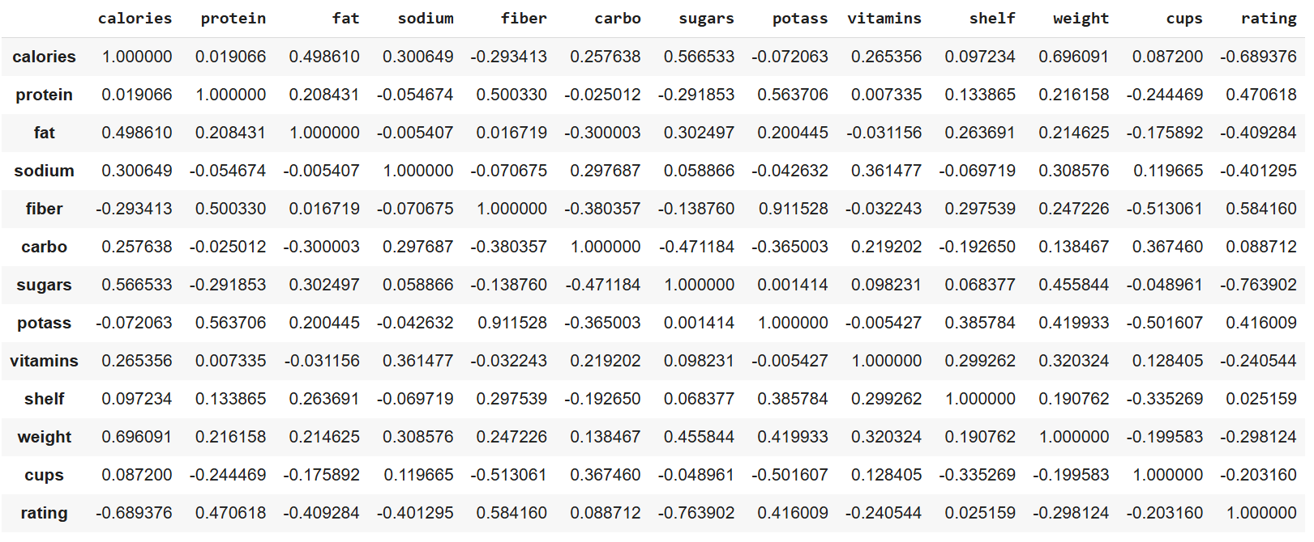
The table above is the result of calling python ntitative_df.corr() library
5. Plot histogram for 'rating'
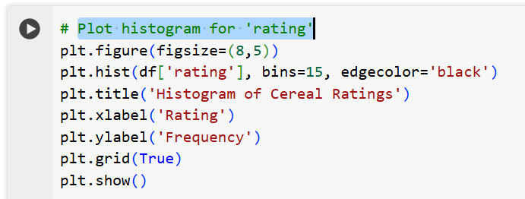
This code creates a histogram to visualize the distribution of cereal ratings.

plt.figure(figsize=(8,5))
- Creates a new figure for the plot.
- figsize=(8,5) sets the width to 8 inches and height to 5 inches.

plt.hist(df['rating'], bins=15, edgecolor='black')
- Plots a histogram of the rating column from the Data Frame df.
- bins=15 divides the rating range into 15 intervals (bars).
- edgecolor='black' adds a black border around each bar for clarity.

plt.grid(True)
- Adds a grid to the background of the plot for better readability.
