Huynh Do Lab#2 Part A:
Objective: This lab assignment exposes student to working with null values, which is data that is missing or is not known within a data set.

- Import libraries
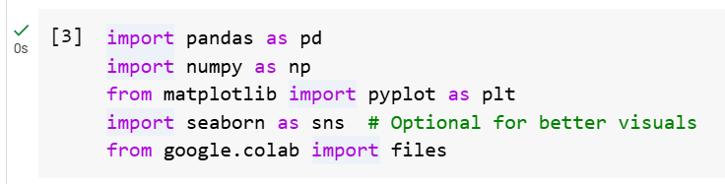
The code above imports several Python libraries commonly used in data analysis.
- import pandas as pd
  - A library for data manipulation and analysis (e.g., working with tables, CSVs, etc.).
- import numpy as np :
  - Support for numerical operations and arrays.
- from matplotlib import pyplot as plt
  - Creating static, interactive, and animated plots.
- import seaborn as sns
  - Imports Seaborn provides prettier and more informative plots.
- from google.colab import files
  - Used in Google Colab to upload/download files from your local system within a Colab notebook.
- Upload file NBA.csv
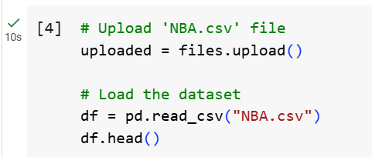

The above screen shot is used to upload and load a CSV file named NBA.csv into a Pandas Data Frame in a Google Colab environment.
When upload is done:
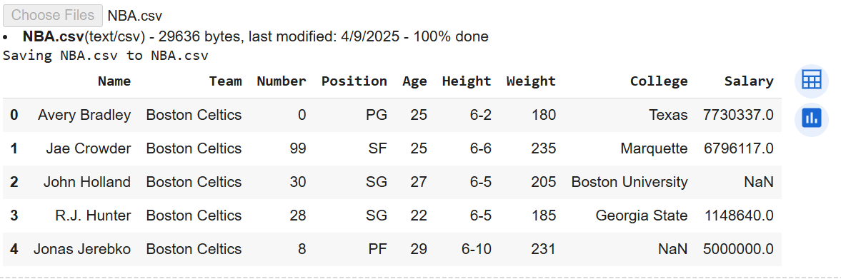
- Process Null Values
- Step 1: Explore null values
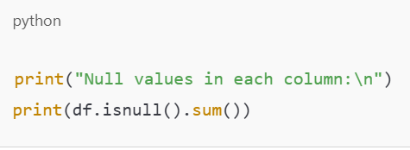
- df.isnull() creates a DataFrame of the same shape as df, where each cell is True if it's null, otherwise False.

- .sum() adds up all the True values in each column (since True = 1), giving us the number of missing values per column.

- Step 2: Fill with Null values
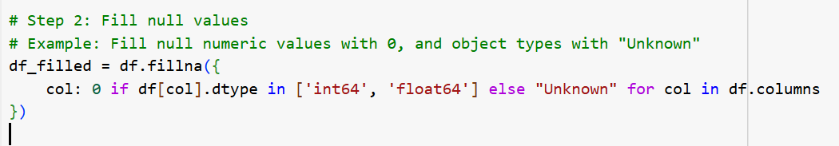
The code above fills missing (NaN) values in a DataFrame (df) by assigning different fill values depending on each column's data type:

- If a column is numeric (int64 or float64), it fills nulls with 0

- Otherwise (usually text, i.e., object), it fills nulls with "Unknown"
In summary: df_filled is a copy of the original df, but with all NaN values replaced:
Numbers → 0 | Strings → "Unknown"
df.fillna({...}) : Uses that dictionary to fill null values column by column, using the specified defaults.

- Step 3: check if all null values are gone
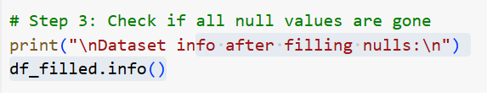
This gives us a summary of the DataFrame after 've filled the missing values. Specifically, it shows:
- Number of entries (rows)
- Column names
- Non-null count for each column — want these to match the total row count if all nulls are gone
- Data types of each column (e.g., int64, float64, object)
- Memory usage

The below is result of calling df_filled.info() function
