Huynh Do Lab#2 Part B:
Objective: Use Python in Google Colab to download your dataset "bikes.csv", to explore and summarize the Regression

- Import libraries
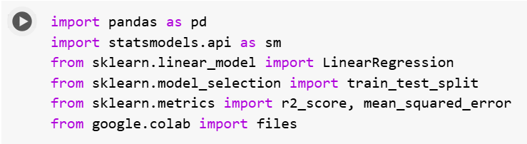
The code above imports several Python libraries commonly used in data analysis.
- import pandas as pd: Brings in Pandas, r go-to library for working with tabular data (like CSV files).
- Use it to load, clean, manipulate, and analyze datasets.
- Example: df = pd.read_csv("data.csv")
- import statsmodels.api as sm :
- This loads Statsmodels, a library for doing deep-dive statistical analysis.Useful for regression with detailed output: coefficients, p-values, confidence intervals, etc.
- Commonly used for OLS (Ordinary Least Squares) regression.
- from sklearn.linear_model import LinearRegression :
- model.fit(X_train, y_train)
- Grabs the Linear Regression model from Scikit-learn.
- Faster, simpler, great for prediction.
- from sklearn.model_selection import train_test_split
- Split r dataset into training and testing sets.
- Ensures 're testing r model on unseen data.
- X_train, X_test, y_train, y_test = train_test_split(X, y, test_size=0.2)
- from google.colab import files
- Used in Google Colab to upload/download files from your local system within a Colab notebook.
- from sklearn.metrics import r2_score, mean_squared_error
- These are tools to evaluate r model’s performance.
- r2_score: How well r model explains the variance (ranges from 0 to 1; higher is better).
- mean_squared_error: Average of the squared differences between predicted and actual values (lower is better).

- Upload file BIKES.csv
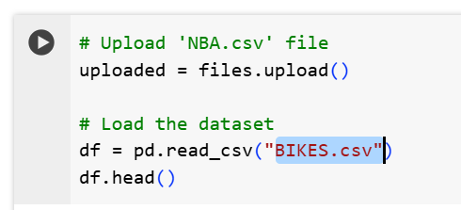

The above screen shot is used to upload and load a CSV file named BIKE.csv into a Pandas Data Frame in a Google Colab environment.
When upload is done:
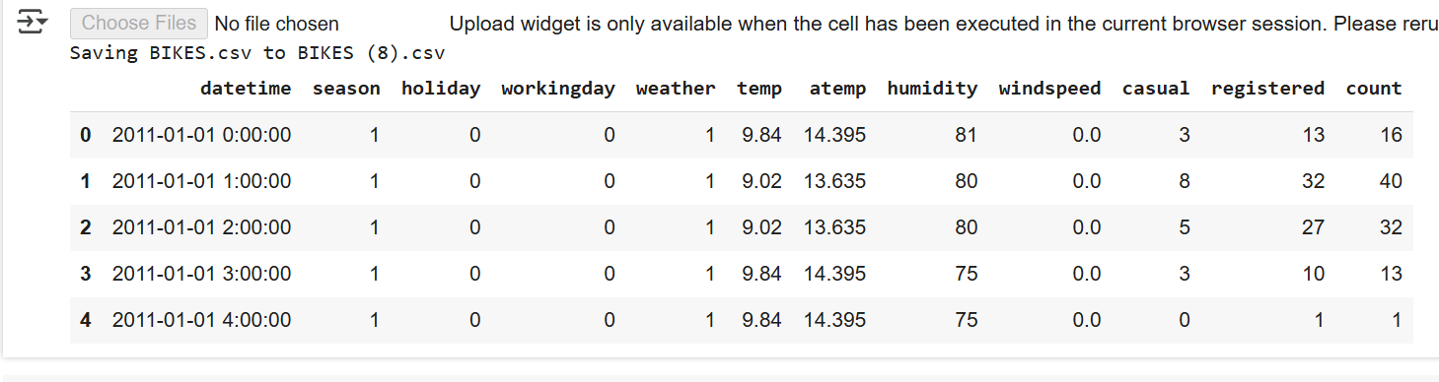
- OLS Regression: count ~ temp
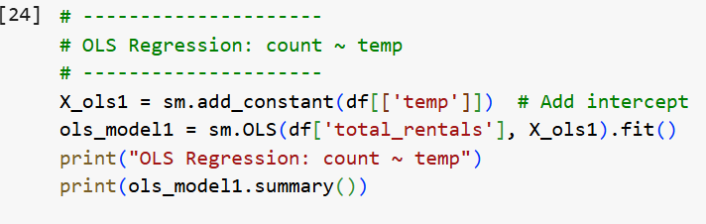
- df[['temp']]
- Selecting the temperature column from the DataFrame df as r independent variable (X).
- Double square brackets [[]] keep it as a DataFrame (not a Series), which is what statsmodels expects.
- sm.add_constant(...)
- OLS (Ordinary Least Squares) needs an intercept term — a baseline value when all predictors are 0.
- X_ols1 = sm.add_constant(df[['temp']]) adds a column of 1s to r X matrix so r model can learn the intercept (i.e., y = b0 + b1 * temp).
- sm.OLS(df['total_rentals'], X_ols1
- This sets up an OLS regression model, predicting: total_rentals ~ temp where: df['total_rentals'] = dependent variable (what you're trying to predict, aka y)
- .fit()
This trains the model using data:
It computes the best-fit line using least squares and returns an object (ols_model1) that stores all the regression results.
- print(ols_model1.summary()):
This prints out a detailed regression summary, including:
- Coefficients (slope and intercept)
- Standard errors
- Summary
- The result predicts that temp actually has a statistically significant impact — or if it's just hot air.
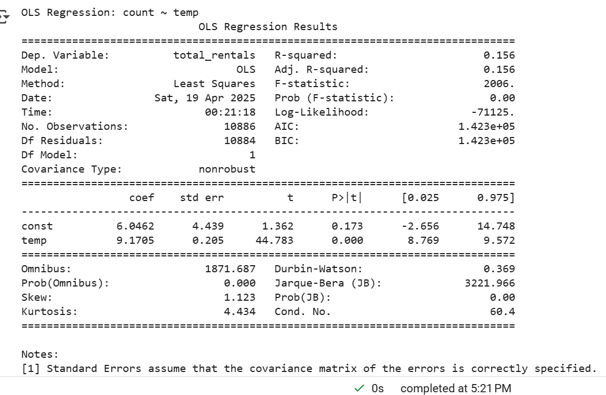
The above figure is the result of running the OLS Regression python code

- Sklearn Linear Regression: count ~ temp

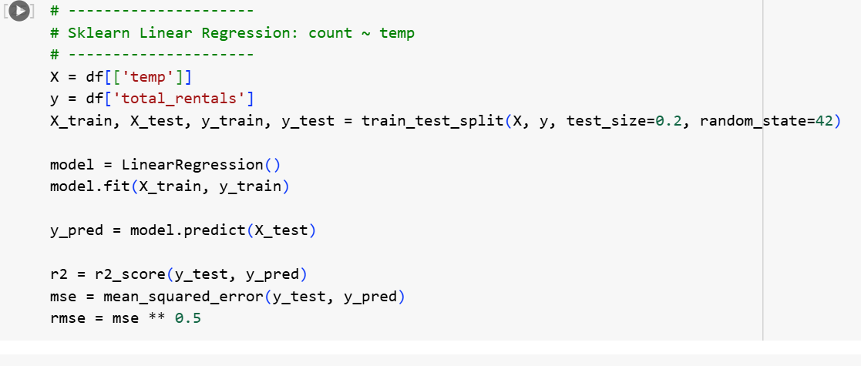
- train_test_split(...)
- X_train, X_test, y_train, y_test = train_test_split(X, y, test_size=0.2, random_state=42)
- Splits data:80% for training and 20% for testing
- random_state=42 ensures reproducibility (so get the same split every time)
- model = LinearRegression()\
- model.fit(X_train, y_train)
- Trains the model using the training data.
- Learns the best-fit line: total_rentals ≈ b0 + b1 * temp
- y_pred = model.predict(X_test)
Predicts rental counts using the test set temperatures.
Gives a list of predicted values based on the learned model.
- r2 = r2_score(y_test, y_pred)
- Calculates R-squared, which tells how well r model explains the variability in the data.
- Ranges from 0 to 1:
- 1 = perfect prediction
- 0 = no better than guessing the mean
- mse = mean_squared_error(y_test, y_pred)
MSE = average of squared prediction errors
Lower = better
Sensitive to outliers due to squaring
- rmse = mse ** 0.5
RMSE = Root Mean Squared Error
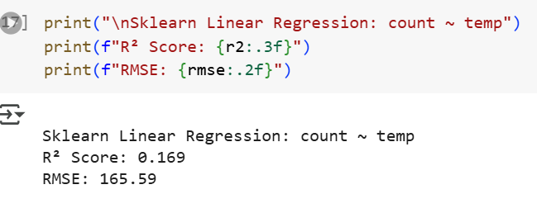
The above figure showed the final results
Quick summary:
- Temperature does have an effect on rentals.
- Warmer days = more rentals. The relationship is statistically significant.

