Huynh Do Lab#3:
Objective:
This lab assignment works with Principal Component Analysis (PCA) to expose how they can determine the best explained variance ratio. This is a statistical procedure that is used to reduce dimensionality

- Import libraries
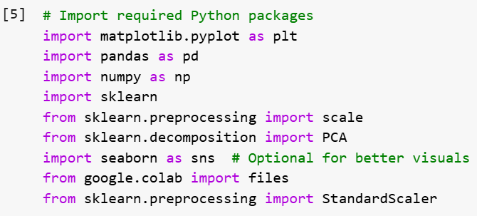
The code above imports several Python libraries commonly used in data analysis.
  - matplotlib.pyplot – Used to create basic graphs like scatter plots, line charts, and bar graphs.
  - pandas – Loads and manages tabular data (like CSVs) into an easy-to-use DataFrame.
  - numpy – Powers fast mathematical operations, especially with large arrays of numbers.
  - sklearn – Provides machine learning algorithms and data processing tools.
  - scale – Instantly standardizes your data to have a mean of 0 and variance of 1.
  - PCA – Reduces the number of variables while keeping the important patterns in your data.
  - seaborn – Makes fancier, cleaner-looking graphs with less code than plain matplotlib.
  - google.colab.files – Lets you upload and download files when working inside Google Colab.
  - StandardScaler – Another way to standardize data, but more control across train/test splits.

- Upload file b5.csv

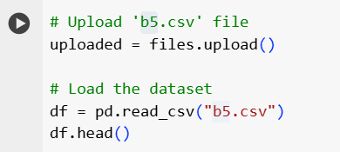
The above screen shot is used to upload and load a CSV file named b5.csv into a Pandas Data Frame in a Google Colab environment.
When upload is done:
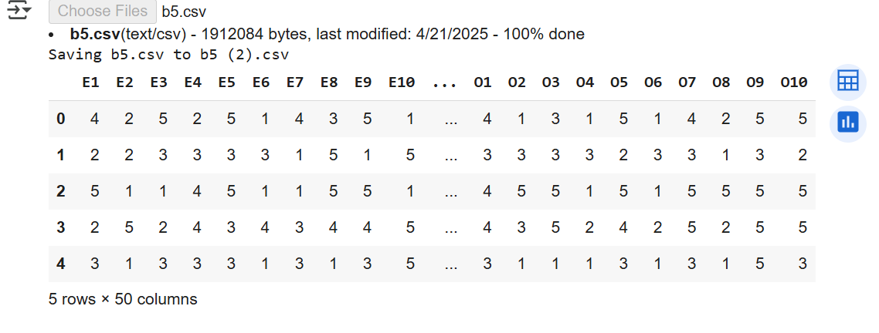
- Process PCA

- Step 1

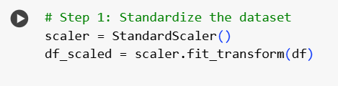
- scaler = StandardScaler() Creates a scaler object to standardize features (zero mean, unit variance).
- df_scaled = scaler.fit_transform(df) Fits the scaler to the dataset and transforms the data into a standardized form.

- Step 2

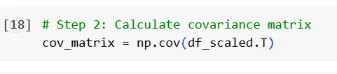

- cov_matrix = np.cov(df_scaled.T) Calculates the covariance matrix by transposing the standardized data so features are treated as variables.

- Step 3

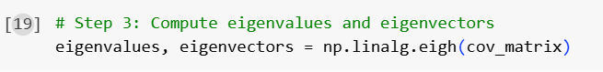
- eigenvalues, eigenvectors = np.linalg.eigh(cov_matrix) Computes the eigenvalues and eigenvectors of the covariance matrix to find directions and magnitudes of variance.

- Step 4

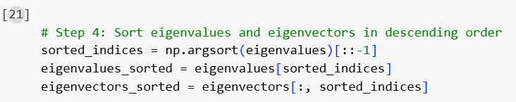
- sorted_indices = np.argsort(eigenvalues)[::-1] Finds indices that sort eigenvalues from largest to smallest.
- eigenvalues_sorted = eigenvalues[sorted_indices] Reorders eigenvalues in descending order.

- Step 5

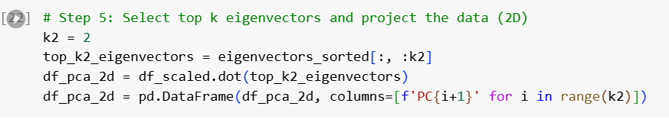

- k2 = 2 Sets the number of principal components to keep at 2 for 2D projection.
- top_k2_eigenvectors = eigenvectors_sorted[:, :k2] Selects the first two sorted eigenvectors.
- df_pca_2d = df_scaled.dot(top_k2_eigenvectors) Projects the standardized data onto the 2D principal component space.
- df_pca_2d = pd.DataFrame(df_pca_2d, columns=[f'PC{i+1}' for i in range(k2)]) Converts the projected data into a labeled DataFrame with PC1 and PC2.

- Step 6
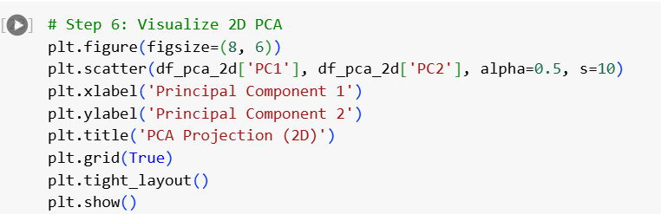

- plt.figure(figsize=(8, 6)) Creates a new figure with specified size.
- plt.scatter(df_pca_2d['PC1'], df_pca_2d['PC2'], alpha=0.5, s=10) Plots the 2D PCA result as a scatter plot.
- plt.xlabel('Principal Component 1') Labels the x-axis.
- plt.ylabel('Principal Component 2') Labels the y-axis.
- plt.title('PCA Projection (2D)') Adds a title to the plot.
- plt.grid(True) Enables grid lines for better readability.

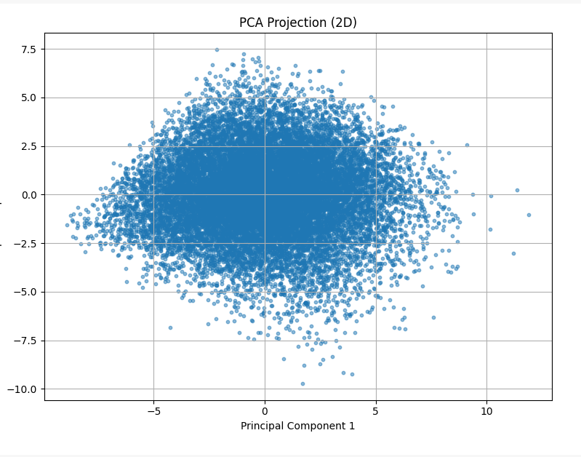

- Total summary
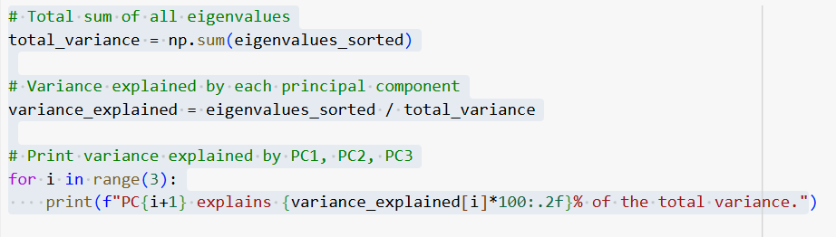
PC1 explains 16.10% of the total variance.
PC2 explains 9.25% of the total variance.
PC3 explains 7.53% of the total variance.

