Huynh Do Lab#6:

Objective: This lab assignment exposes you to other classifiers that we can try, such as K-Nearest Neighbors (KNN), Decision Trees, Random Forests, and Naive Bayes. The goal of this exercise is to predict using a variety of classifiers, including GaussianNB, DecisionTreeClassifier, and KneighborsClassifier
- Import libraries
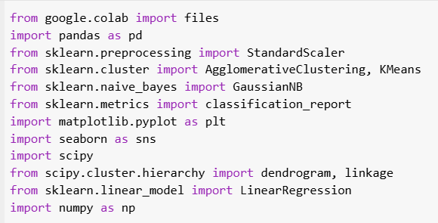
The code above imports several Python libraries commonly used in data analysis.
Data Handling and Manipulation:
- pandas: Used for data manipulation, reading datasets, and organizing data in tabular form.
Data Standardization:
- StandardScaler: Scales data to have zero mean and unit variance, ensuring that all features contribute equally to clustering and classification.
Clustering Algorithms:
- AgglomerativeClustering: Implements hierarchical clustering, merging data points iteratively to form clusters.
- KMeans: Divides data into a specified number of clusters by minimizing distances to cluster centroids.
Classification Algorithm:
- GaussianNB: A probabilistic classifier that assumes feature distribution is Gaussian (normal). It predicts classes based on calculated probabilities.
Model Evaluation:
- classification_report: Generates metrics like precision, recall, F1-score, and support to assess classification performance.
Data Visualization:
- matplotlib: A plotting library for creating visualizations like scatter plots and line charts.
Statistical Analysis and Clustering:
- scipy: Offers scientific computing functions, including hierarchical clustering and generating dendrograms.
Linear Regression:
- LinearRegression: Fits a linear model to the data, estimating the relationship between input features and a target variable.

- Upload file ClusterData.csv

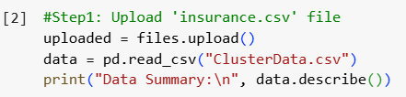
After uploaded
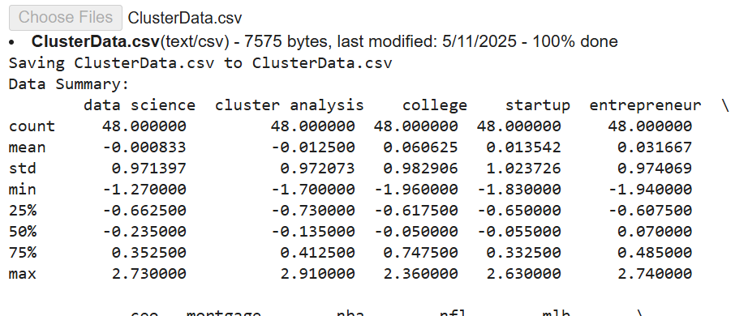

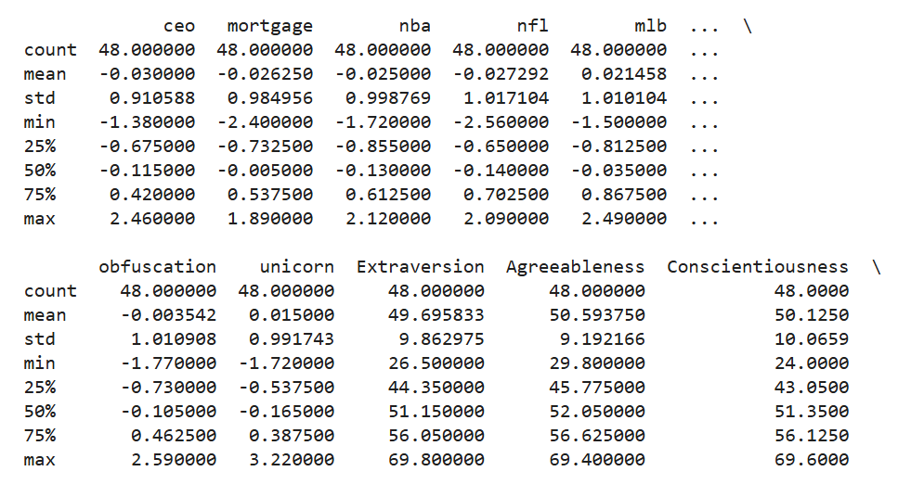
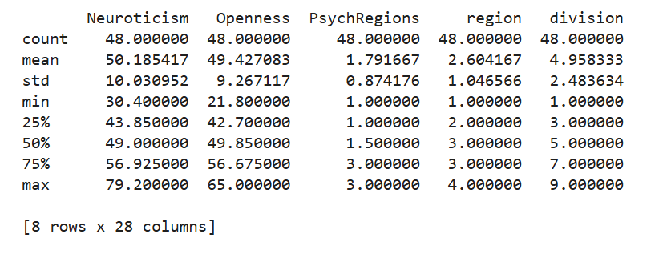

- Process data

- Step2: Drop categorical columns

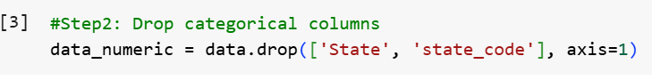
- The dataset contains both numerical and categorical variables.
- State and state_code are categorical columns containing text data that are not suitable for clustering or classification without encoding.
- The drop() function is used to remove these columns, ensuring that only numerical data remains for further analysis.
- This step is crucial because clustering and GaussianNB classification require numerical inputs to calculate distances and probabilities. By excluding non-numerical data, we prevent potential errors and maintain data consistency.

- Step3: Standardize the data
To bring all numerical features to a common scale (mean = 0, standard deviation = 1).
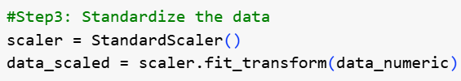
- Different features in the dataset might have different ranges (e.g., some values might be in the range of 0-1, while others might be in the range of 100-1000). If left unscaled, features with larger ranges could dominate the clustering process, skewing the results.
- StandardScaler() calculates the mean and standard deviation for each feature and transforms the data as follows:
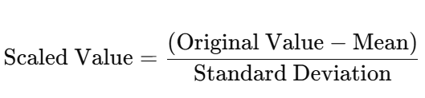
- This transformation ensures that each feature contributes equally to the clustering and classification process.

- Step4: Apply Hierarchical Clustering
To group similar data points into clusters based on their distance or similarity.
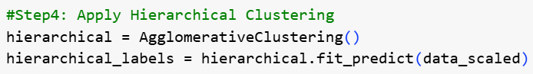
- Hierarchical Clustering is an iterative process that either merges or splits clusters based on their similarity.
- We are using Agglomerative Clustering, which is a bottom-up approach:
  - Each data point starts as its own cluster.
  - The algorithm iteratively merges the closest clusters based on a linkage criterion (default is 'ward' linkage, minimizing variance).
Implementation:
- AgglomerativeClustering() initializes the model.
- fit_predict() computes the clustering and assigns a cluster label to each data point.
Why Hierarchical Clustering?
- It provides a detailed visual representation of how clusters are formed and merged over iterations.
- Unlike KMeans, it does not require the number of clusters (k) to be defined upfront.

- Step5: Apply KMeans with k=7

To partition the dataset into 7 clusters based on similarity.

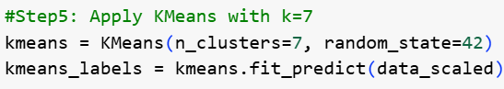
- KMeans Clustering is a centroid-based algorithm that divides data into kkk clusters.
- The algorithm works in the following steps:
  - Initialization: Randomly selects 7 initial centroids.
  - Assignment: Assigns each data point to the nearest centroid based on Euclidean distance.
  - Update: Recalculates the centroids by averaging the data points in each cluster.
  - Iteration: Repeats steps 2 and 3 until centroids stabilize (no further changes in assignments).
Parameters:
- n_clusters=7: Specifies the number of clusters.
- random_state=42: Ensures reproducibility by controlling the random number generation.
Why KMeans?
- It is computationally efficient and works well for well-separated, spherical clusters.
- The number of clusters must be specified in advance, unlike hierarchical clustering.
- Step6: Apply Gaussian Naive Bayes:
To classify data points into categories based on probabilities calculated using the Gaussian distribution.

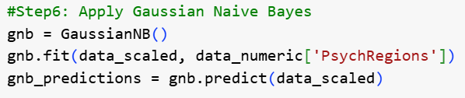
How It Works:
- Training (fit):
  - data_scaled: Input features, which are standardized numerical data.
  - data_numeric['PsychRegions']: Target variable containing categorical labels (e.g., 1, 2, 3).
  - The algorithm learns the mean and variance of each feature for each class.
- Prediction (predict):
  - Calculates the probability of each class for each data point using the Gaussian distribution formula:
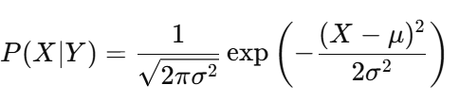
  - Assigns the class with the highest probability.
- Step7: Classification report
To evaluate the performance of the Gaussian Naive Bayes model by analyzing its predictions against the actual labels.

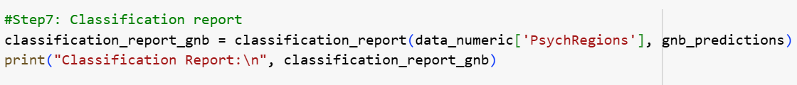
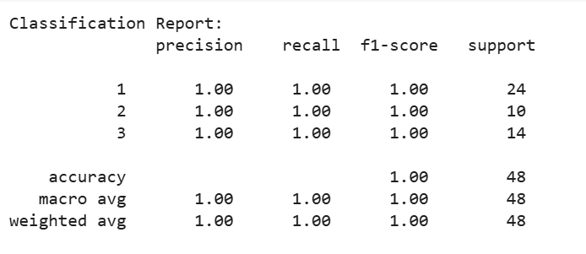
What is a Classification Report?
- The classification report provides a summary of key performance metrics for each class in the target variable. It includes:
    - Precision: The percentage of correctly predicted positive observations out of all predicted positive observations.
    - Recall: The percentage of correctly predicted positive observations out of all actual positive observations.
Implementation:
- classification_report() compares the actual labels (data_numeric['PsychRegions']) with the predicted labels (gnb_predictions) and calculates these metrics.
Why the Classification Report?
- It helps assess how well the model performed for each class and provides insight into where the model may be underperforming (e.g., low precision or recall for specific classes).
- Step8: Visualize KMeans Clusters

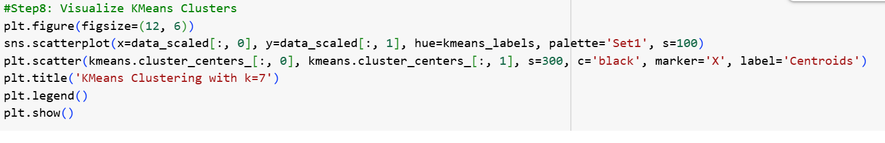
- Plotting the Clusters:
  - Each data point is plotted and colored based on its assigned cluster label.
  - Different colors indicate different clusters, allowing us to visually distinguish the data groups.
- Cluster Centroids:
  - Centroids (mean position of data points within each cluster) are marked with black 'X' markers.
  - These centroids represent the central points of each cluster and are useful for identifying cluster centers.
- Regression Line:
  - A linear regression line is fitted through the data points.
  - The purpose of the regression line is to identify any linear relationship between the two main plotted features.
  - The slope and direction of the line provide insight into how the features are correlated (positive, negative, or no correlation).

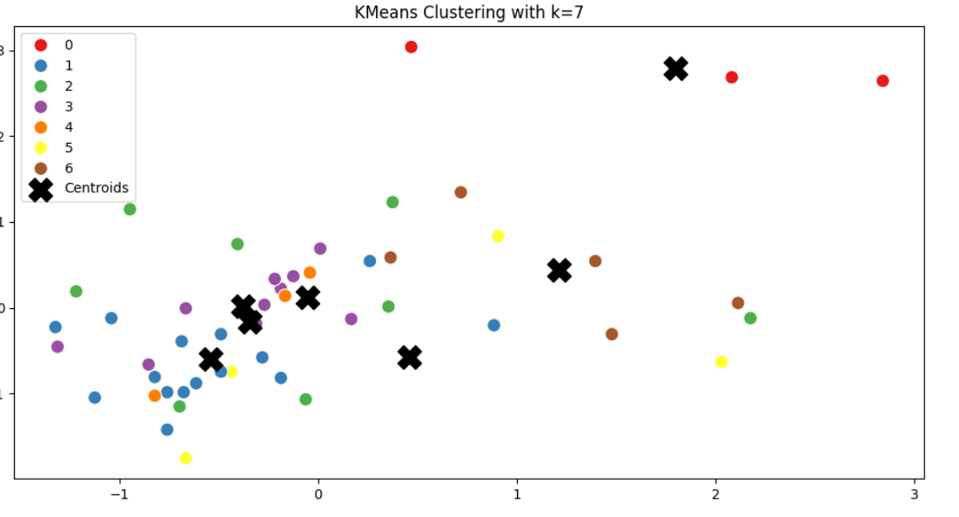

- Interpretation:
- Clusters:
- Each point in the scatter plot represents a data point, colored based on its assigned cluster (from 0 to 6).
- The colors indicate distinct clusters formed by the KMeans algorithm.
- The black 'X' markers represent the centroids of each cluster, which are the mean positions of all data points within that cluster.
- Interpretation of Clusters:
- Data points close to the same centroid are more similar to each other in terms of feature values.
- Clusters that are far apart indicate distinct groups of data with different characteristics.
- Clusters that overlap or have points scattered across multiple centroids may indicate weaker separation between those data groups.
- Application:
- This visualization is useful for identifying data patterns, assessing how well the clustering performed, and observing potential correlations between the two main plotted features.
- Conclusion:

- Clustering Analysis:
- Hierarchical Clustering identified natural groupings in the data based on distance/similarity, visualized through a dendrogram. The merging process indicates how data points are clustered step-by-step.
- KMeans Clustering (k=7) effectively divided the dataset into 7 clusters. The visualization clearly shows cluster centroids, with distinct groups formed based on feature similarities.
- Classification Analysis:
- Gaussian Naive Bayes was applied to predict the target variable PsychRegions. The model achieved a perfect classification accuracy of 1.00, as indicated in the classification report.
- This result suggests that the features used for clustering are highly informative and well-separated in terms of defining the PsychRegions classes.
- Overall Insights:
- The clustering successfully identified distinct data groupings, and the GaussianNB model effectively classified the data based on the PsychRegions target variable.
- The perfect accuracy in classification indicates a high degree of feature separability but may also suggest overfitting, especially if the dataset is relatively small.
- The regression line provides a simple linear relationship but does not capture complex patterns beyond linear trends.

