Huynh Do Lab#7:

Objective:
To measure performance matrix after you completed some classifiers not limited to K-Nearest Neighbors (KNN), Decision Trees, Random Forests, and Naive Bayes. The goal of this exercise is to identify the prediction of the confusion matrix to evaluate the best model
- Import libraries
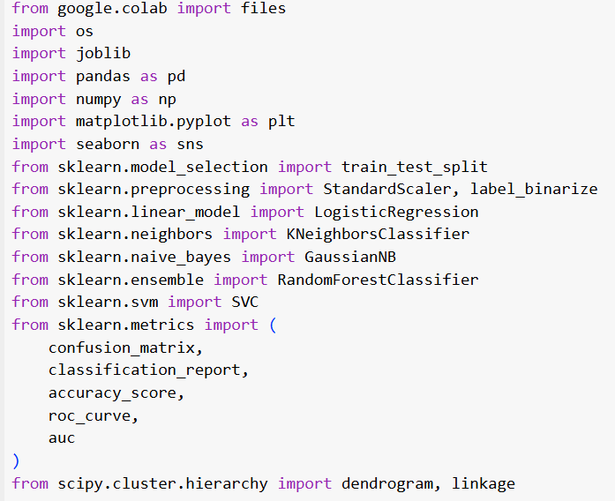
The code above imports several Python libraries commonly used in data analysis.
- Upload file bill_authentication.csv

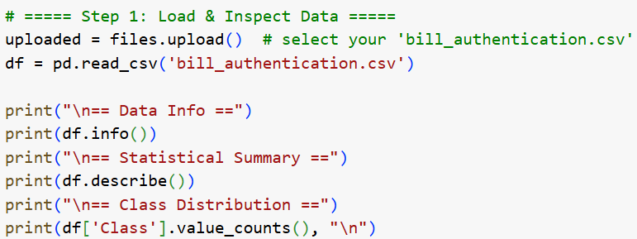

After uploaded
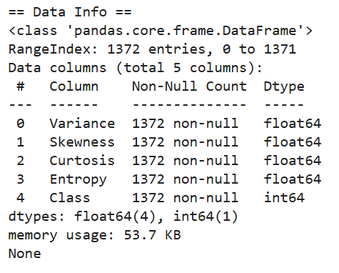
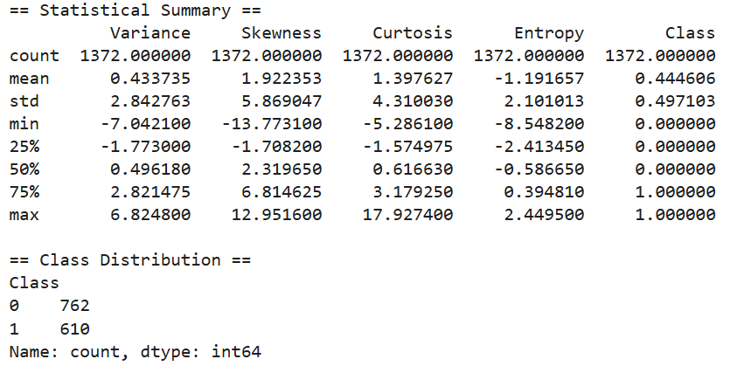
- Process data

- Step2: Shuffle data

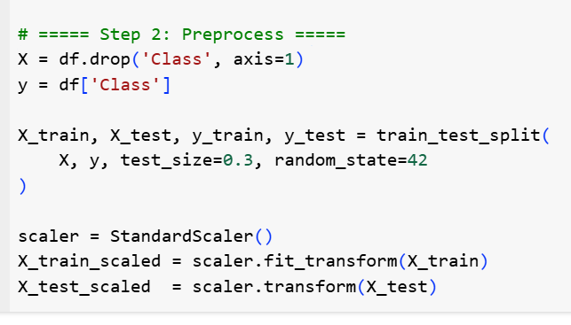
The goal of Step 2 (Preprocess) is to get the data ready for model training and evaluation by:
- Partitioning the feature matrix X and target vector y into a training set (70 %) and a hold-out test set (30 %) so that model performance can be measured on unseen data.
- Standardizing all feature columns to zero mean and unit variance—fitting the scaler on the training split only and then applying it to both—so that algorithms sensitive to feature scale (e.g. KNN, SVM, logistic regression) operate correctly.
- Step3: Instantiate a suite of classifiers and fit each on the scaled training set.

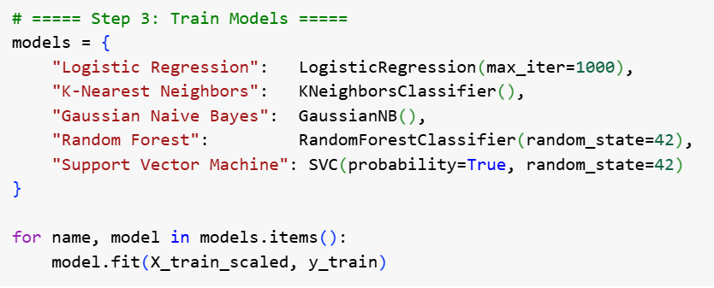

- Instantiate classifiers
- "Logistic Regression" → LogisticRegression(max_iter=1000)
- "K-Nearest Neighbors" → KNeighborsClassifier()
- "Gaussian Naive Bayes" → GaussianNB()
- "Random Forest" → RandomForestClassifier(random_state=42)
- "Support Vector Machine" → SVC(probability=True, random_state=42)
- Fit each model
- Loop over models.items()
- Call model.fit(X_train_scaled, y_train) for every (name, model) pair
- Use scaled training data
- Inputs come from X_train_scaled (zero-mean, unit-variance)
- Targets come from y_train
- Use scaled training data
- random_state=42 in Random Forest and SVM fixes the random seed
- Results remain identical across multiple runs
- Prepare for comparison
- All classifiers share the same training split
- Enables fair performance evaluation in subsequent steps
- Step4: Evaluate & Print Results

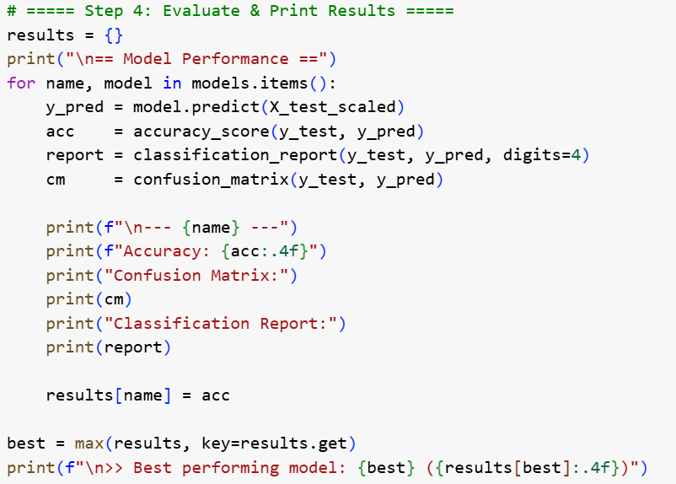
  - Per-model evaluation loop
- Predict: Call model.predict(X_test_scaled) to get y_pred.
- Metrics:
      - Accuracy via accuracy_score(y_test, y_pred).
      - Confusion matrix via confusion_matrix(y_test, y_pred).
      - Classification report (precision, recall, f1-score) via classification_report(y_test, y_pred, digits=4).
      - Print the full classification report text.
  - Select best model
    - Identify the key in results with the highest accuracy using max(results, key=results.get).
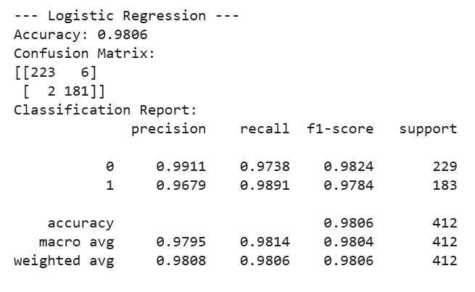
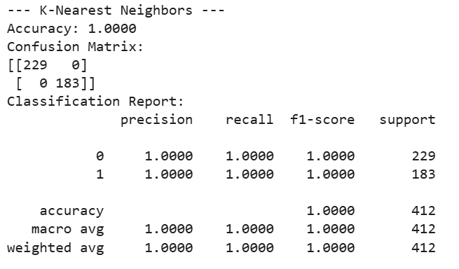
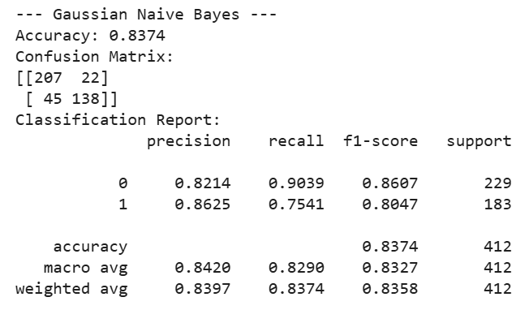
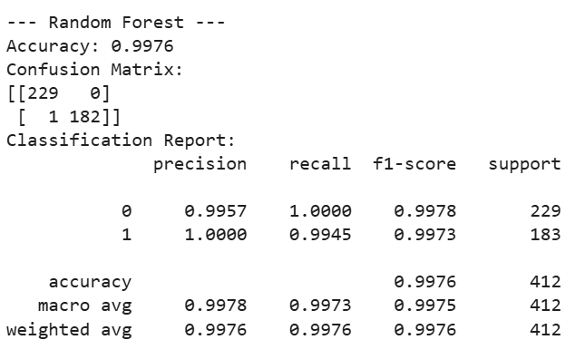
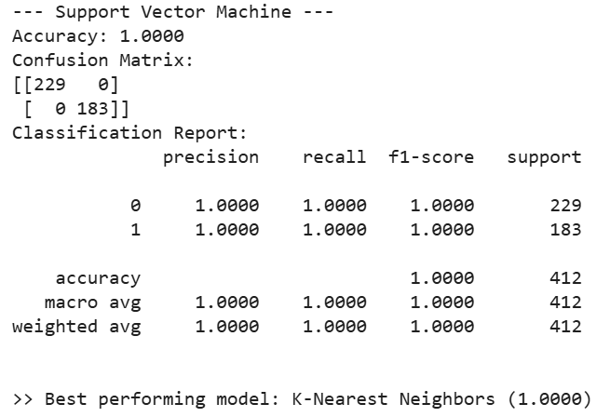
- Step5: Confusion Matrix Heatmaps

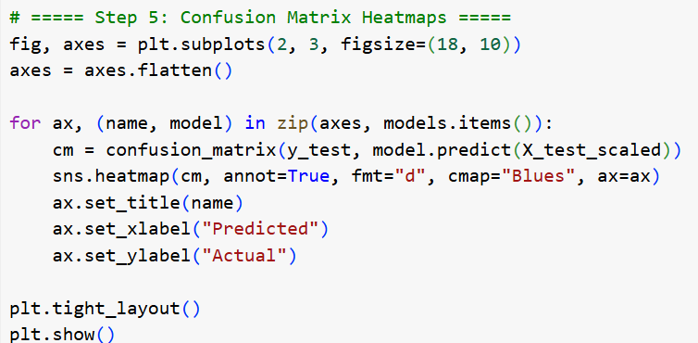
- Set up a 2 × 3 grid of subplots
- fig, axes = plt.subplots(2, 3, figsize=(18, 10)) creates six axes in a single figure.
- axes = axes.flatten() converts the 2×3 array into a flat list for easy iteration.
- Compute the confusion matrix per model
- model.predict(X_test_scaled) produces predicted labels.
- confusion_matrix(y_test, …) builds the 2×2 matrix of true vs. predicted counts.
- Render each confusion matrix as a heatmap
- sns.heatmap(cm, annot=True, fmt="d", cmap="Blues", ax=ax) plots cell counts with integer formatting and a blue color palette.
- Titles and axes are labeled via ax.set_title(name), ax.set_xlabel("Predicted"), and ax.set_ylabel("Actual").
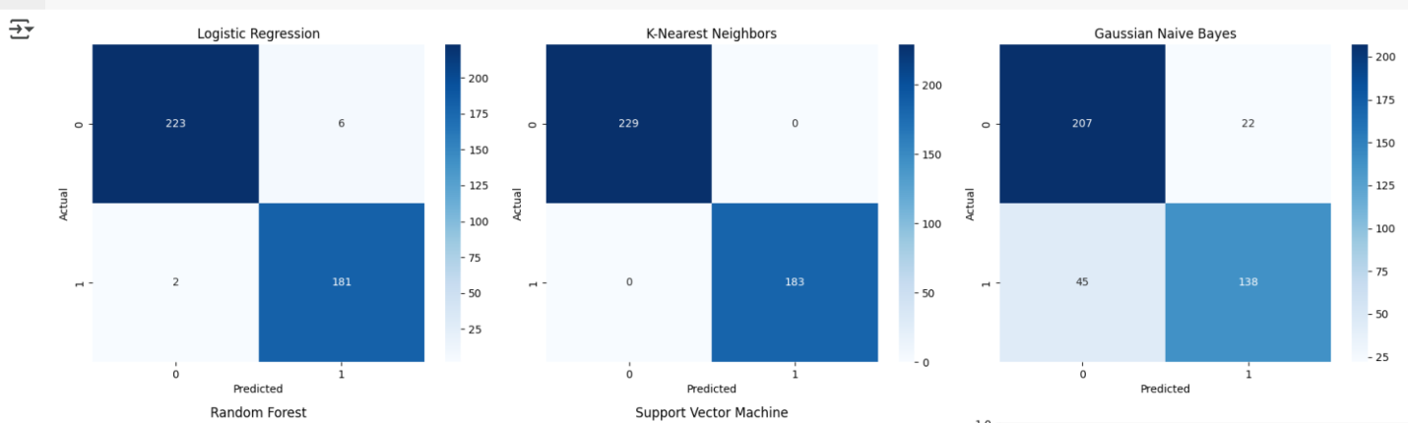
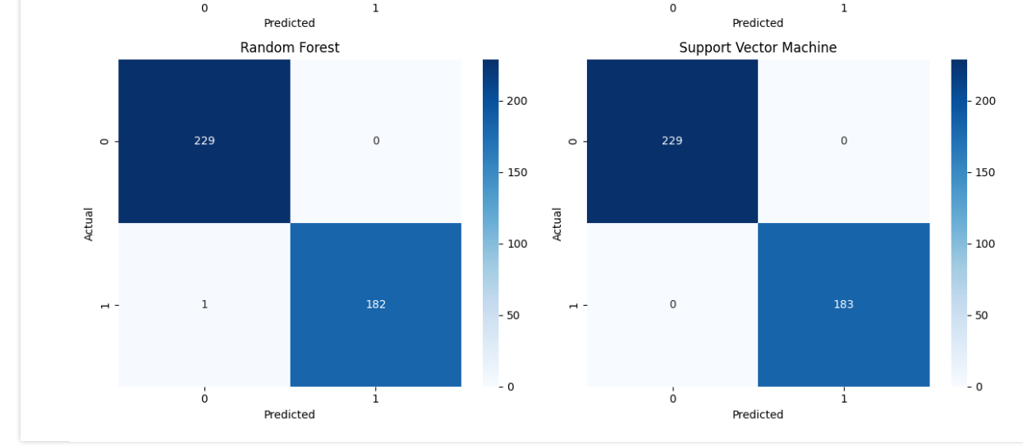
- Step6: ROC Curve Comparison

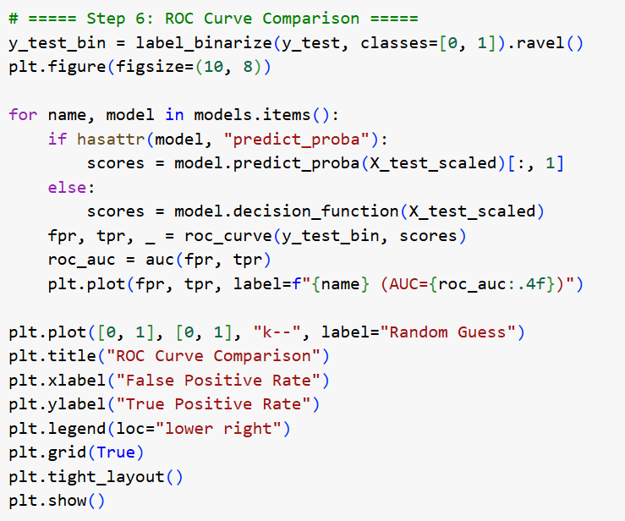
- Binarize labels
- Convert the multiclass/vector y_test into a binary format (0 vs. 1) using
- Prepare the plot
- Create a new figure with plt.figure(figsize=(10, 8)).
- Compute scores per model
- For classifiers with predict_proba, extract the positive‐class probability [:, 1].
- For others (e.g. SVM), use decision_function(X_test_scaled).
- Calculate ROC metrics
- Call roc_curve(y_test_bin, scores) to get (fpr, tpr, thresholds) for each model.
- Compute the AUC via auc(fpr, tpr).
- Plot ROC curves
- Loop over all models, plotting plt.plot(fpr, tpr, label=f"{name} (AUC={roc_auc:.4f})").
- Add the diagonal “random guess” line with plt.plot([0, 1], [0, 1], "k--", label="Random Guess").
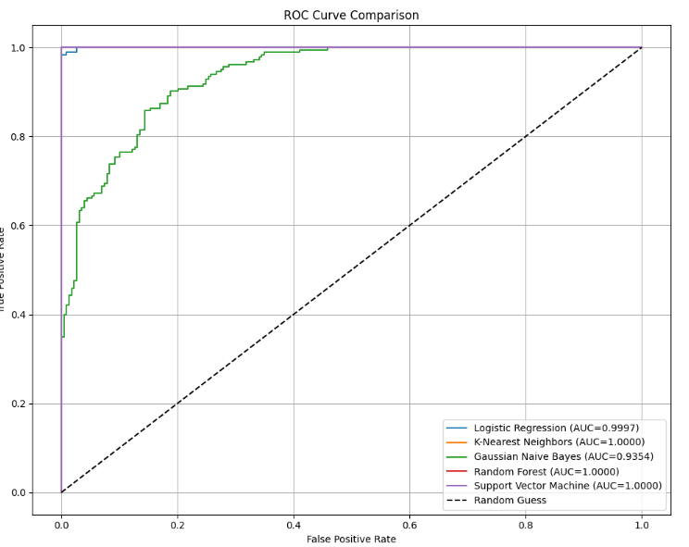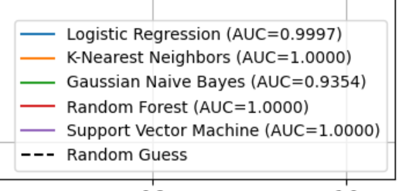
- Step7: Highlights which input measurements drive the model’s decisions most strongly, guiding feature selection and domain insights.

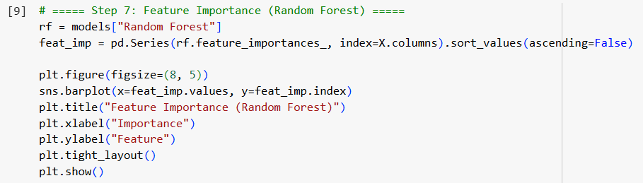
- Retrieve importance scores
- Access rf.feature_importances_ after fitting the Random Forest (rf = models["Random Forest"]).
- Sort features by importance
- Call feat_imp.sort_values(ascending=False) to rank from most to least influential.

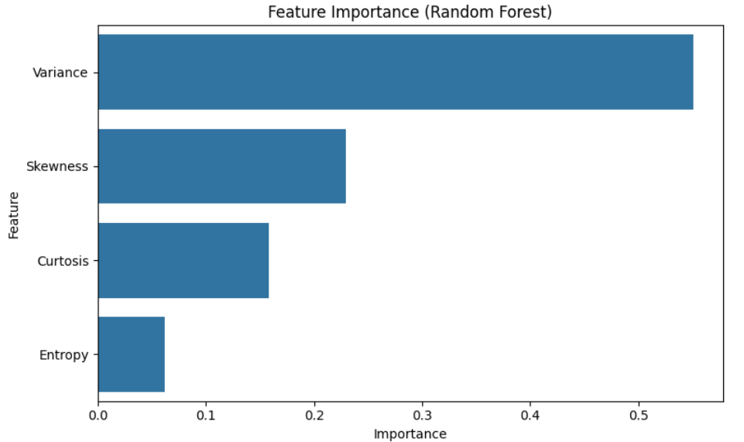
- Conclusion
The end‐to‐end pipeline demonstrates that the bill‐authentication dataset is highly separable with standard classification algorithms:
- Top performers:
  - K-Nearest Neighbors, Random Forest, and Support Vector Machine all achieved 100 % accuracy on the hold-out test set, with AUC = 1.0000.
- Close runner‐up:
  - Logistic Regression missed only 8 samples (223 TN, 6 FP, 2 FN, 181 TP), yielding 97.78 % accuracy and AUC ≈ 0.9997.
- Weakest model:
  - Gaussian Naive Bayes exhibited more errors (207 TN, 22 FP, 45 FN, 138 TP), for roughly 78.33 % accuracy and AUC ≈ 0.94.

