Name: Huynh Do – Assignment 1

Hypothetical Research: The Impact of Maternal Stress Levels During Pregnancy on Birth Defects

Objective:
- To determine whether levels of maternal stress during pregnancy are associated with risk of birth defects.

Hypothesis:
- Higher levels of maternal stress during pregnancy are likely causing greater risk of birth defects.

Study:
- Population: Pregnant women stratified into groups based on stress levels:
  - Group A: Low stress.
  - Group B: Moderate stress.
  - Group C: High stress (e.g., chronic stress, trauma, or severe anxiety).
- Sample size: 187,390 women equally distributed across the three groups between the year of 2000 and 2010 in 10 states ( details of data can be found from CDC data )
- Inclusion participants
  - Pregnant women with 18-40 of age and willing to participate in regular stress assessments.
- Exclusion participants
  - Women with history of mental health conditions.
  - Women with history of drug, tobacco and alcohol use during pregnancy.
  - Women with existing medical conditions.
- Variables:
  - Independent variables (IV):
    - Self-reported stress: Using validated questionnaires (e.g., Perceived Stress Scale).
    - Timing of stress: The timing is broken into 3 semesters such as: early, mid and late pregnancy.
    - Intensity of stress: Categorized as low, moderate, or high stress based on survey responses.
  - Dependent variables (DV):
    - Structural of defects: Such as heart defects, cleft lip or brain suffer.
    - Impairments: Such as hearing loss or speed delays.
    - Level of defects: Level could be classified as mild, moderate, or severe.
- This research is non-experimental research

Sampling Strategies and Data Collection:
- Stress measurement:
  - Self-reported or conducted by phone interview: Individual participant will complete validated level of stress in each trimester. For example, using the Perceived Stress Scale (PSS-10) is a 10-item questionnaire originally developed by Cohen is used to assess stress levels in young people and adults aged 12 and above.
  - Internal stress: Such as blood pressure, heart rate etc..
  - Negative life events: Significant life events (e.g., financial hardship, funeral, relationship issues such as divorce etc...) will be recorded and tracked.
- Birth defect screening for outcomes:
  - Newborns will be examined for any sign of birth defects within the first 48 hours.
  - Birth defects will be categorized by type (e.g., heart defects, neural tube defects, brain suffer) and severity (mild, moderate, and severe).
  - Follow up: Newborns will be followed for up to two years to detect any further defects or developmental issues.

Level of measurements of variables:
- Independent Variable (IV): Maternal stress
  - Categorical: If the stress is measured as low, moderate or high, this will be a natural category.
  - Continuous (interval/ratio): If stress is measured by heart rate, blood pressure, this will be categorized as ratio data.
- Dependent Variable (DV): Birth Defects
  - Categorical: If birth defects are found/not found (binary result - Y/N) then this will be nominal data.
  - Categorical: If birth defects are determined by type such as heart defect, cleft lip then also will be considered as nominal data.
  - Ordinal: If birth defects are categorized as level such as: Mild(1), Moderate(2) or Severe(3) then this will be considered as ordinal data with ranked data.

Summary statistics:

Stressful Life Events Experienced by Women in the Year Before Their Infants' Births — United States, 2000–2010:

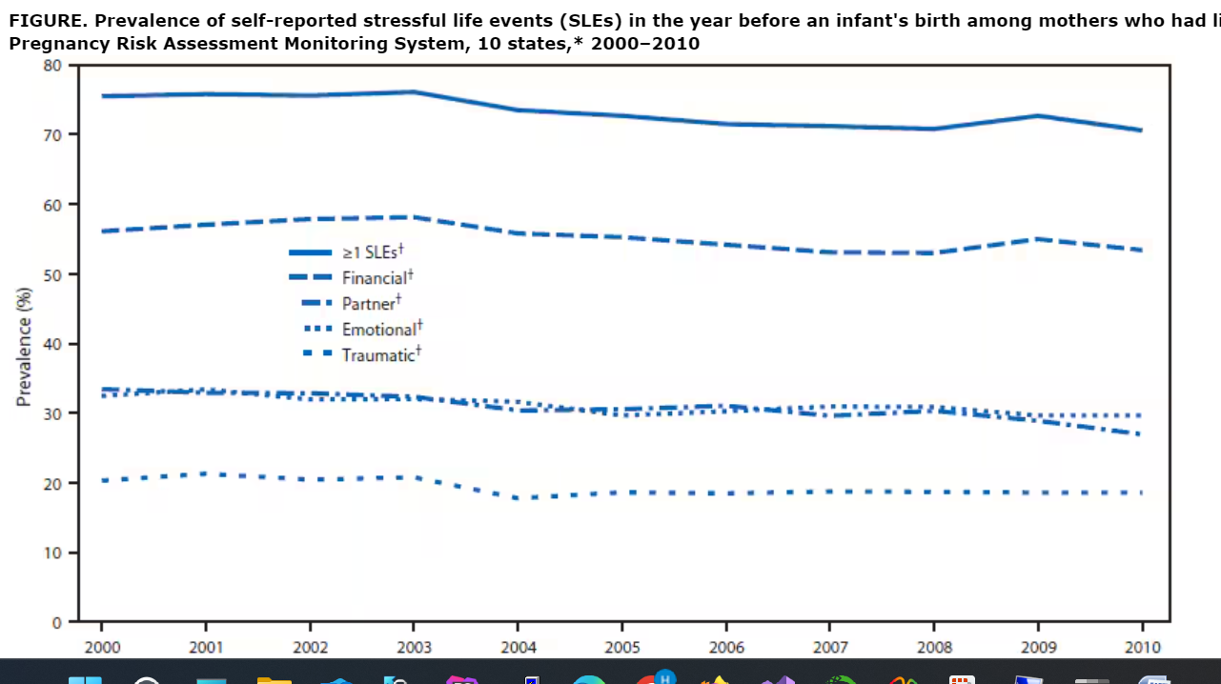
Woman with high level of stress during pregnancy are likely increase the risk of certain birth defects and those including:
- Neural tube defects (NTDs)
- Brain suffer
- Orofacial clefts
- Low birth weight
- Preterm birth
- Peripartum depression

Cited:

Stressful Life Events Experienced by Women in the Year Before Their Infants' Births — United States, 2000–2010:
https://www.cdc.gov/mmwr/preview/mmwrhtml/mm6409a3.htm
National Library of Medicine:
https://www.ncbi.nlm.nih.gov/pmc/articles/PMC2094125/#:~:text=Increased%20stress%20was%20associated%20with,through%20increased%20production%20of%20corticosteroids.
https://www.childrensnational.org/about-us/newsroom/2020/when-pregnant-moms-are-stressed-out-babies-brains-suffer

