HUYNH DO
Module 2, Part 1/2
- Category Explanation of variables:
“Who Do You Vote For”- Categorical: Voting for individual candidate involves selecting a set of options such as “Candidate 1”, “Candidate 2” and so on.
“Health” - Categorical: This is often being grouped as “Good”, “Fair” or “Poor”. Individual health conditions are being considered a category of health status and therefore it is a considered as “Category” statistic.
“Years with current job” – Continuous: This variable measures the length of time (measure in years) someone has been staying with the job and the years can be from 0 to any upper number including fractions (e.g., 2.4, 5.5, 10.5)
“Number of hours usually work a week” – Continuous: The value range from 0 to any floating numbers (5, 2.7 or 23.67 hours) and therefore, the characteristic of this variable is continuous.

- Categorical #1: Who do you vote for – Variable Name: IF16WHO
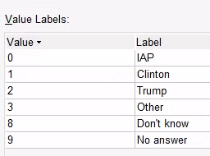
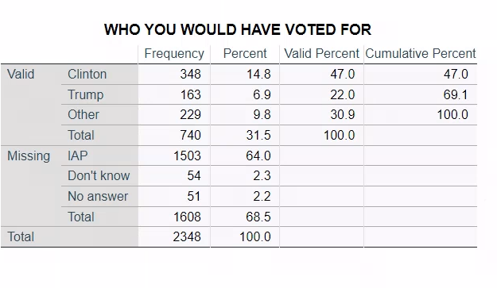
- Calculate the appropriate measures of central tendency for each of the variables and interpret the findings
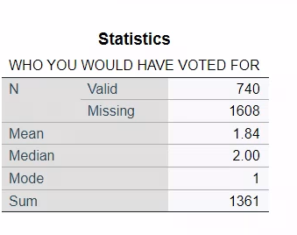

- Analysis of Central Tendency Measures
- Mean (Average): The number 1.84 showed that on average, the participants were about to elect either Clinton (1) or Trump (2) first if not than other candidate (3).
- Median: The number 2.00 (greater than mean – 1.84), this number indicates that 50% of voters will select Trump(2) even Clinton received some more support over Trump
- Mode: The number 1 indicates that Clinton (the highest number of repeats) was the most favorable candidate among Trump and the rest of the candidates.

- Interpret the frequency data:
- Valid Responses:
There are only 740 valid responses (31.5% of total survey), this shows that significant voters did not answer the question or having no preferences.

- Frequency Distribution:
- Clinton was the leading with 348 votes or 47% valid responses.
- Trump only received 163 votes, making up 22% of the valid responses.
- Other candidates make up the rest of valid response with 229 votes or 30.9%
- Missing Data:
- 1503 participants or 64% selected “IPA” suggesting they either did either fill out the survey incorrectly or opt out the answering the survey questions
- Additionally, 2.3% indicated that they have no idea or don’t know, and 2.2% provided “No answer”.

- Central Tendency Measures Findings
The statistic was suggesting voters were favoring Clinton over on both Trump and other the candidates.

- Calculate the appropriate measures of variability for each of the variables and interpret the findings

- Analysis of Key Descriptive
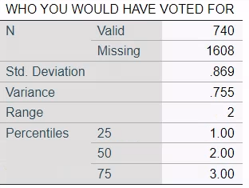

- Standard Deviation (0.86): This number is very close to 0, this indicates voters were mostly keeping eyes on main options (Clinton, Trump, Other)
- Variance (0.77): This suggests voters have moderate variability preferences.
- Range (2): The range 2 implied (between lowest 1 and highest 3) that voters will select a candidate in the survey rather than saying “No answer”.
- Percentile
- 25th Percentile (1): Voters mostly choose Clinton
- 50th Percentile (2) : Half of voters will either choose Clinton (1) or Trump (2)
- 75th Percentile (3): 75% of voters will choose either Clinton or Trump while the rest will choose “Other”

- Create a bar chart, pie chart and histogram and interpret the results.

- Bar chart
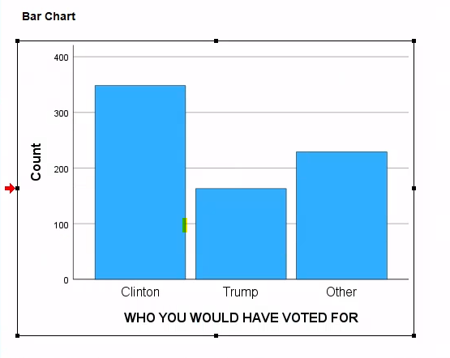
This particular data, the number of supports for “Clinton” stands out of the chart, followed by “Other” and “Trump” receiving the least.

- Pie Chart

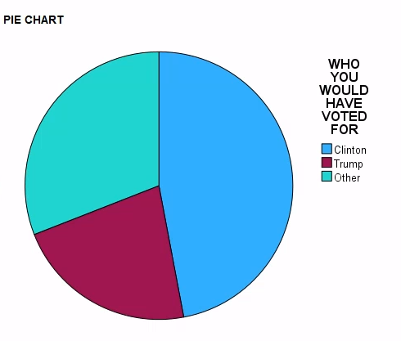
Clinton makes up the most portions (47%) of the valid responses
Trump is the least portion of the chart (22%)
Other makes up almost 31%
- Histogram
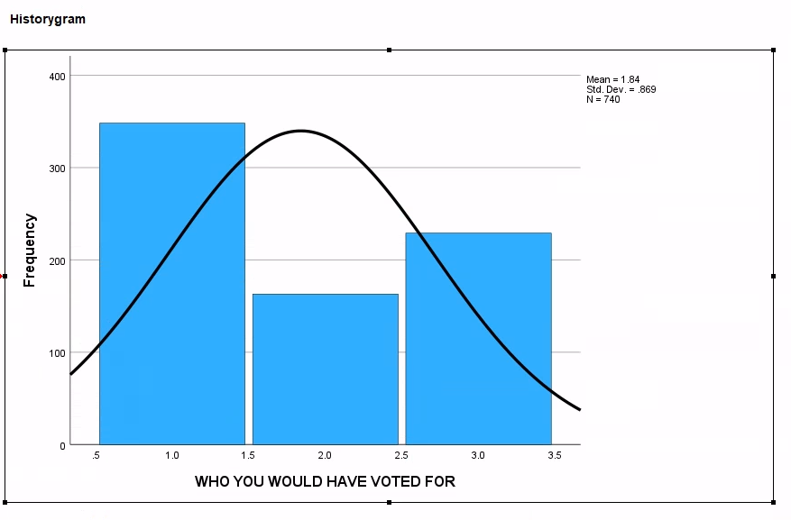

The distribution indicates that Clinton was the most favorable choice.

- Categorical #2: Health – Variable View: HEALTH1

- Calculate the appropriate measures of central tendency for each of the variables and interpret the findings
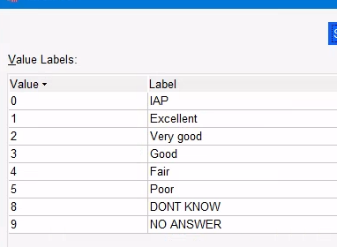

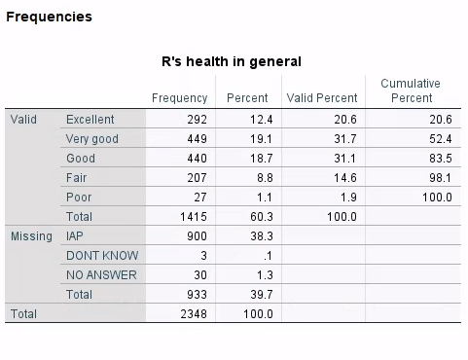
- Analysis of Central Tendency Measures
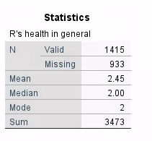
- Mean (Average): The number 2.45 lies between Very Good (2) and Good (3) indicates that, on average, the participants feel very healthy about their health conditions with slightly downgrading to “Good” condition.
- Median: The median 2.00 showed that the 50% of the participants feel they are very healthy (Very Good - 2) or even better, while the other half feel only Good (3) or worse.
- Mode: The mode is 2 which tell us that the majority of the population is rating their hearths in “Very Good - 2” conditions.

- Interpret frequency data
- Valid Responses:
A total of 1,415 valid responses meaning these responders reported their health conditions.
- Frequency Distribution
- Excellent and Very Good: Together, 52.4% of participants consider happy with their current health conditions (from Very Good -> Excellent).
- Good: 31.1% indicates that almost 1/3 of the participants rate their health condition in “Good” condition
- Fair: the 14.6% is a small portion of participants record their health conditions are just OK, however, this percentage is still noticeable number.
- Poor: Quite a few cases (1.9%) report that their health conditions are “Poor”.
- Missing Data
- More than 1/3 (933 - 38.3%) of responders marked as IPA or “Not answer” probably fall into another category or their true health conditions may vary from time to time.

- Tendency Measures Findings:
In general, the statistic of health condition is mostly “Good” with most responders.

- Calculate the appropriate measures of variability for each of the variables and interpret the findings
  - Analysis of Key Descriptive
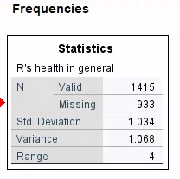

- Standard Deviation (1.034): This number means that most ratings are just either 1 point expanding from left or right of the mean (2.45). This shows that the rating does not deviate widely from the mean. So, in summary, this number suggests that the cluster is relatively close to the average healthy condition “Very Good” to “Good”.
- Variance (1.068): The variance is low, it suggests that most participants’ health condition are not too far from mean (2.45)
- Range (4): This number indicates that the we have data across the spectrum from “Excellent -1 ” and all the way up to “Poor – 5” range.

  - Percentiles
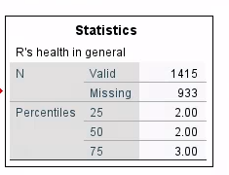

- 25th Percentile (2): The value of 2 indicates that 25% or lower report “Very Good” condition.
- 50th Percentile (2): This shows that 50% of participants are very happy with their health conditions (Very Good) or better, while the other half report only “Good” down worse.
- 75th Percentile (3): 75% of population rate their health as 3, which correspondents to “Good”

- Create a bar chart, pie chart and histogram and interpret the results.

- Bar chart
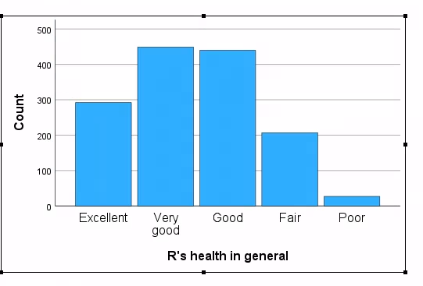
From this chart, we can see that the frequencies of “Very Good” and “Good” health conditions are the dominant responses followed by “Excellent”.

- Pie Chart
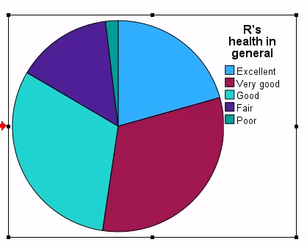

From this chart, together “Good” and “Very Good” make a large portion of the pie, while “Poor” has relatively small share of it

- Histogram
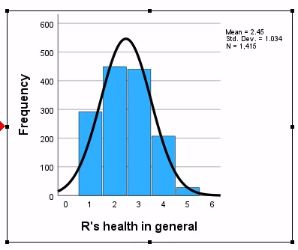
The chart shows us the frequency distribution of participants are concentrated in positive health conditions which are “Good”, “Very Good” while “Poor” has the least.
Conti
- nuous #1: Time at current job – Data Row: YEARSJOB
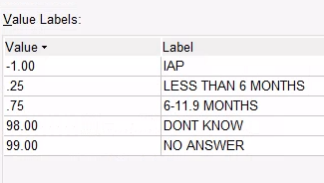

- Calculate the appropriate measures of central tendency for each of the variables and interpret the findings
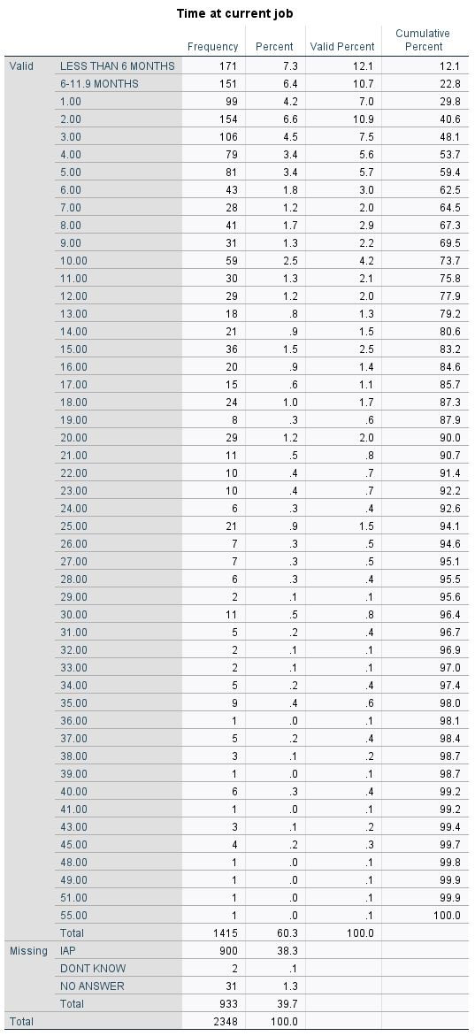
- Analysis of Central Tendency Measures
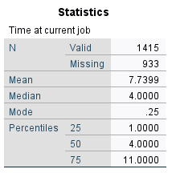

- Mean (Average): The number 7.73 shows that, on average, employees have been in their current job for 7 years and 8 months. However, the mean is higher than both the median and much higher than the mode, this suggests that there are a few senior employees (outliers) who have been with the company for exceptionally longer periods ( 40+ years )
- Median: The number 4 years tells us that 50% of the employees have been at their current job. Since the Median is lower than the Mean which tells us that a few senior employees pulling the mean upward.
- Mode: The number 0.25 (3 months) is the majority of how long the employee stays in the job, specially less than 6 months. This concludes that the employer has a high rate of turnover rate.

- Interpret frequency data
- Most Common Time Intervals ( Less than 5-year mark):
    - Less than 6 months: 171 reports (12.1%) is the largest group of employees who have been at their job for a relatively short period
    - 6-11.9 (Almost a year): This group makes up 10.7%
    - From 1 year – Less than 2 years: There are 154 employees responded to this period.
    - From 2 years – 3 years: Together, this group makes (10.9 % + 7.5%) 18.4% of the total.
- Seniority
- By the 5th year of tenure, 59.4% cumulative percent have been in their job
- After 10 years, 73.7% cumulative percent have stayed with the company
- A few employees have been with the current job exceptionally long time (from 48 years to 55 years)

- Tendency Measures Findings:
The data shows that the majority of the employees spend less than 5 years on the job. While there are a few special cases (outliers) that have been with the company for a very long time. The statistic also indicates that this company has a high turnover rate which indicates that perhaps, long-term relationships are less common among the junior level employees.
- Calculate the appropriate measures of variability for each of the variables and interpret the findings

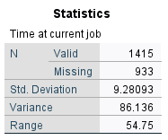

- Analysis of Key Descriptive
- Standard Deviation (9.28):
This number shows that most employees stay within the range of [mean – 9.28, mean + 9.28] where mean = 7.74 years. This wide range suggests that this is a high standard deviation because a few outliers contribute this factor.
- Variance (86.13):
Again, this is a high variance and it confirms that there’s a large diversity in how long people stayed in their current job with very-short term workers as well.
- Range (57.75):
This indicates how much longer in years of service are when comparing between the longest tenure and the shortest one. The huge range indicates that there are presences of outliers with some special employees who have dedicated almost entire of their life to the same job, while others have just recently started a couple of months ago. This is not unusual because, for example, rail-road employees usually stay with the company for a very long time even when they retire.

Percentiles:

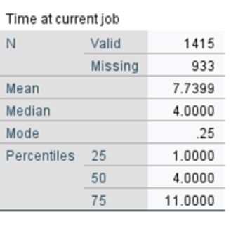
- 25th Percentile (1): With 25% of respondents, this suggests that a considerable portion of employees are still at junior levels (new).
- 50th Percentile (4): 50% of workers have been reach 4-year mark or less than 4 years.
- 75th Percentile (11): 75% of employees have been at their job for 11 years or less, which translate to only 25% of the employees has been in their current jobs for more than 11 years.
- Create a bar chart, pie chart and histogram and interpret the results.

- Bar chart

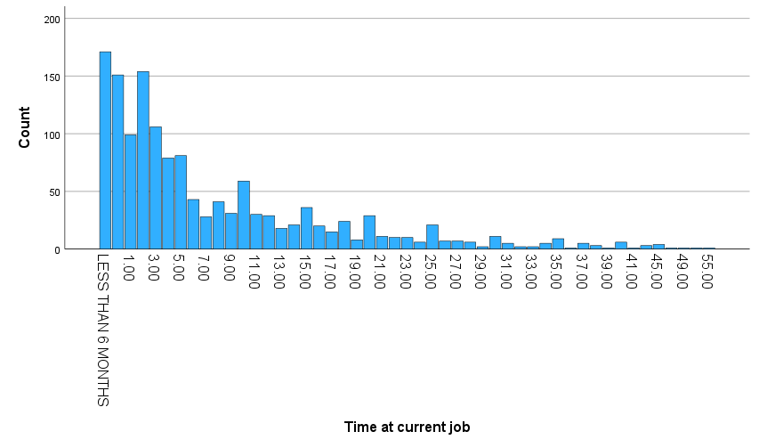
The chart shows that a large portion of the employees is relatively new to their current job, with most workers having been at their jobs for less than 5 years.

- Pie Chart

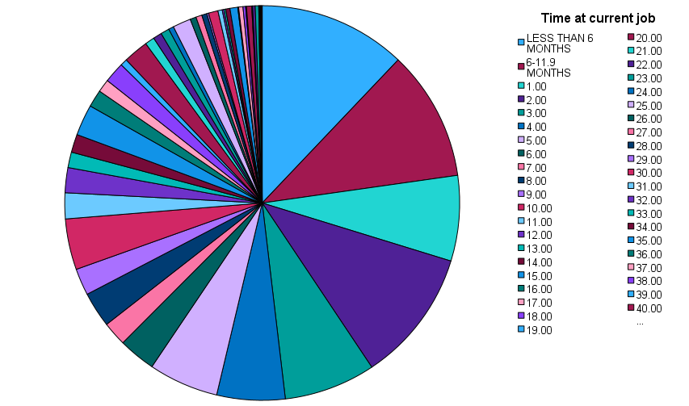

Interpretation of Findings from the Pie Chart:
- Dominance of Short Tenures:
This chart shows that a big portion of workers have been at their jobs for less than 5 years. Specially, employees have been employed for less than 6 months (12.1%) and 6-11.9 months (10.7%) make up the largest slice. This reflects a workforce where shorter tenures are common, possibly due to high turnover or a young workforce.

- Mid Level:
The segments for job tenures between 1 to 5 years also make up noticeable portion of the chart. Together, job tenures of 5 years or less making nearly 60% of the employees. This indicates that the majority of employees are relatively new to the jobs.

- Senior Level:
The slices for tenures beyond 10 years become progressively smaller, showing that only a small fraction of respondents have been at their job for long periods. Employment tenures of 20 years or more are very small slices of the chart, indicating that long-term employment is relatively rare in this sample.

- Outliers:
Exceptionally seniors (e.g., 40+ years) make up a tiny portion of the pie.

- Histogram
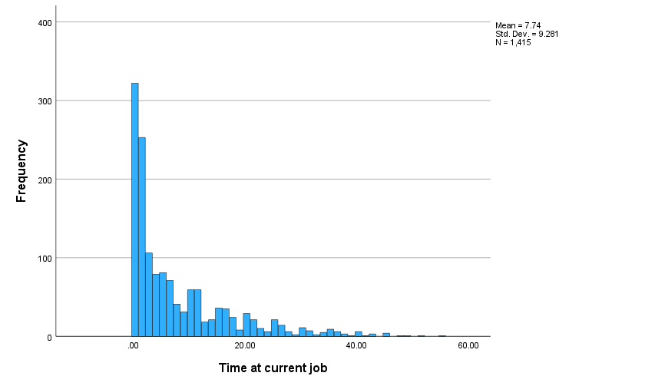

Interpretation of Findings from the histogram:
The graph shows us that the total employees having worked at their current job for less than 5 years are the dominant group, while quite a few employees have been staying with the company for an exceptionally long time. The graph also shows us that this employer experiences a very high turnover rate.

Peak in Short Term:
Less than 6 months and 6-11.9 months, reinforcing that many respondents are relatively new to their jobs. This peak shows that most employees are clustered around short job durations.
- Decline in longer Years In Service:
Along years in service, after 5 years, the height of each bar is shorten drastically compare to the peek, Very few respondents have worked for 20 years or more, as seen in the declining bars toward the right of the histogram.
- Outliers in Extreme:
There are a few outliers employees respondents with extremely long tenures (30 years or more), but these are rare occurrences, are very small counts to the chart.

- Calculate z-scores for the continuous variables. Are there any outliers?
From the calculated z-scores data from the SPSS, these z-scores fall into absolute value fall in between [3-5.10]: 3.15, 3.2, 3.79, 4.66, especially 5.09 are over absolute 3, therefore, they are considered outliers.

How to calculate the z-scores:
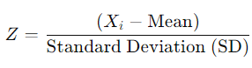
Where: Xi​ is the value of the data point.
For example the outlier has the z-score of 5.09375, which corresponds to 55 years, is calculated as follow:
5.09375 = ( 55 - 7.73 ) / 9.28

- Continuous #2: Number of hours usually work a week – Data View:HRS2

- Calculate the appropriate measures of central tendency for each of the variables and interpret the findings
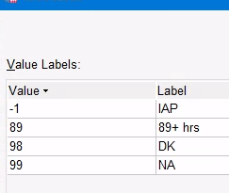
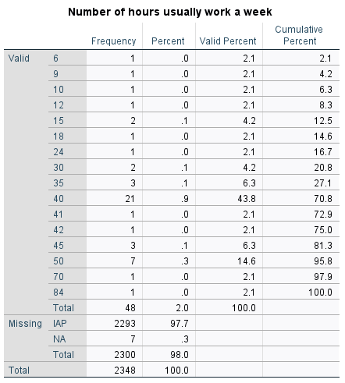

- Analysis of Central Tendency Measures
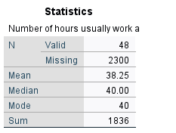
- Mean (Average): The mean number of hours usually worked per week is 38.25 hours. This indicates that, on average, the workers spend around 38 hours and 15 minutes per week.
- Median: The median number of hours worked per week is 40 hours. This shows that 50% of the workers work either 40 hours or more while the other half work less than 40 hours per week.
- Mode: The mode is 40 hours, meaning that the majority of the employees spend a typical full-time 40 hours per week. This also suggests that there is some kind of good work-life balance here.
- Interpret frequency data:
- The numbers of hours are diversified across participants, but a large percentage (43.8%) of people report working 40 hours per week.
- A few people report working overtime with very long hours (e.g., 50, 70, 84 hours), but these numbers are less common.
- Central Tendency Measures Findings:
The data shows a common work pattern full-time 40 hours per week, with a few people report working overtime with at least 50 hours per week (e.g., 50, 70, and 84 hours); however these numbers are less common.
- Calculate the appropriate measures of variability for each of the variables and interpret the findings
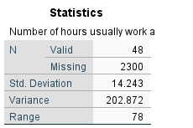
- Analysis of Key Descriptive
- Standard Deviation (14.24):
- The standard deviation is 14.24 hours, which means which means that, on average, the number of hours worked has range of [mean – 14.24, mean + 14.24] where mean = 38.25 hours.
- I considered this is a high standard deviation which implies that some workers work much fewer or long overtime hours compared to the average.

- Variance (202.87):
- Variance suggested that there’s a wide dispersion the data points
- Range (78 hours):
- The range is 78 hours, meaning that the some employees work only a few hours per week (6 hours), while someone put 84 hours per week.

- Percentiles
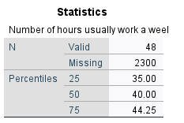

- 25th Percentile (35): 25% of workers put 35 hours or less in a week.
- 50th Percentile (40) : Half or workers (50%) work 40 hours or less. This median is central value that is not affected by extreme values and indicates that a typical hours-per-week is 40 hours.
- 75th Percentile (44.25): 75% of workers put 44 hours per week, however, there are some special circumstances that require workers to put extra hours beyond the regular 40 hours such as: 50 to 70 hours.

- Create a bar chart, pie chart and histogram and interpret the results.

- Bar chart
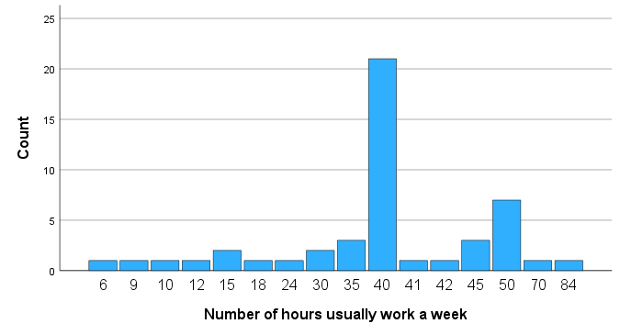
40 hours per week stands out with the highest frequency of 21 participants, indicating that a typical full-time workweek is the most common. Some report working overtime (e.g., 45, 50 to 84 hours). The distribution shows that typical 40 hours work week with few overtime.

- Pie Chart
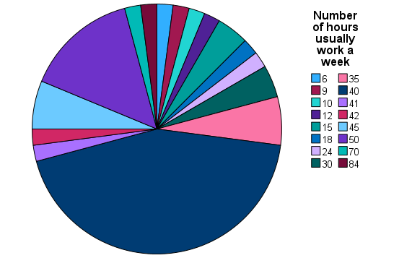

40 hours per week makes up the largest portion of the pie which indicates that 40 hours per week category is the majority responses while there are some much smaller portions with much longer hours.

- Histogram

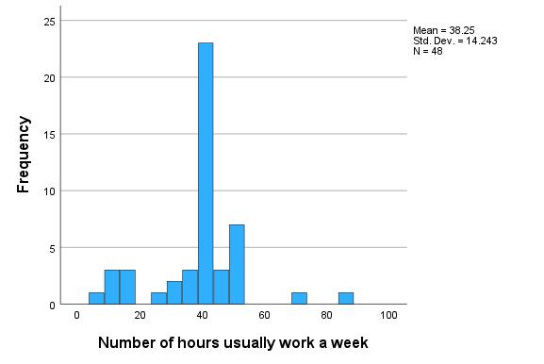

40 hours per week is the most frequent, shown as the tallest bar, confirming it’s the most favorable work-hour per week. However, there are some workers prefer to work only a few hours a week verses someone is willing to put a very long hours at work. The histogram also helps to visualize how drastically the height of the bars are dropped beyond the 40 hours

- Calculate z-scores for the continuous variables. Are there any outliers?

Based on the z-scores table, only the 84-hours has a z-score of 3.21 which is greater than a typical absolute 3. Therefore, the number 3.21 is the outlier corresponding to 84 hours while other values do not exceed the typical threshold for being considered outliers
How to calculate the z-scores:

s
Where: Xi​ is the value of the data point.
For example the outlier has the z-score of 3.2127, which corresponds to 84 hours, is calculated as follow:
3.2127 = ( 84 - 38.25 ) / 14.24

