HUYNH DO
Module 7, Part 1/2
Choose at least five variables from the GSS2018 data file to create a decision tree model.
- Specify which variable is the dependent and independent variable
Module 7 will use a decision tree model that predicts income based on the degree earned, major, race, and employment status, providing insights into how these factors contribute to income prediction.
The following variables are as followed:
- Dependent Variable (DV):
- The Total Family Income INCOME16: This is measured on a scale and is considered a continuous variable.
- Independent Variable (IV) :
- COLDEG1: The highest degree earned such as: Associate, Bachelor Degree etc…
- MAJOR1: Covers a wide variety of majors in Art, Engineering, and Business.
- RACE: While, Black, and Other
- LAIDOFF: Yes/No

- State the goal/purpose of the decision tree model
The primary goal of the decision tree model is to predict and understand the factors influencing Total Family Income by identifying meaningful splits in the data based on specified independent variables. Based on combinations of predictor values, the decision tree divides the data into various groups, represented by nodes, and offers information on how these elements work together to affect the outcome variable.

Individual sub objectives: The model will attempt to answer these main concerns:
- Prediction
- Each calculated node of the population, the model tried to predict the average total family income for individuals based on demographic, educational, and employment-related factors (e.g., College Major, Race, Laid Off Status, etc.).
- Segmentation
- Each terminal node represents a unique segment with a predicted value, which was created through a series of splits algorithm, the model highlights different segments of the population that share similar characteristics and income outcomes.
- Interpretability
- The decision tree structure provides a transparent and interpretable way to understand how different variables and their interactions contribute to variations in family income.
- The model allows for a visual and straightforward explanation of how specific factors, such as education or race, impact income at each level.
- Identifying Key Predictors:
- The model helps identify the most important predictors of family income and how they interact with one another. By doing so, it informs which factors have the greatest impact and may warrant further attention or intervention.
- Generalization
- The model aims to provide predictions that generalize well to new data, offering reliable insights beyond the training sample. Proper validation ensures that the model's splits and predictions hold true across different datasets.
- Overall Purpose:
The decision tree model's purpose is to build a predictive framework that explains and forecasts total family income based on selected predictors. It offers a segmented understanding of the data while maintaining interpretability and actionable insights.

- Create the decision tree using part of the dataset for a training sample and the remainder of the sample for a test sample

- Descriptive
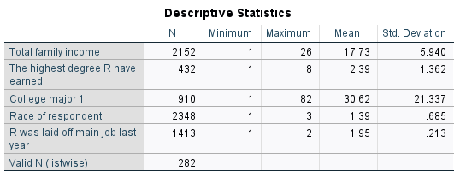

The descriptive statistics offers a quick glance on how independent variable factors are related to family income status.

- Total Family Income - INCOME16
- N: 2,152
- Minimum= 1
- Maximum= 26
- Mean = 17.73
- Standard Deviation = 5.940
- A total of 2,152 random people agree to participate in this survey. The average total family income is 17.73 unit or $17,730, with a standard deviation of 5.940 or [$17,730 +- $5,490], suggesting moderate variability around the mean.
- The Highest Degree Earned - COLDEG1
- N: 432
- Minimum = 1
- Maximum = 8
- Mean = 2.39
- Standard Deviation =1.362
- Out of 432 people who possess a degree, with mean degree level is 2.39, indicating that a Bachelor's degree and beyond (On a degree scale, 2: B.S, 3: M.S) can be found easily among this group. Especially with a standard deviation of 1.36 proves that people are aiming for Master or even PhD degrees.
- College Major - MAJOR1
- N: 910
- Minimum = 1
- Maximum = 82
- Mean = 30.62
- Standard Deviation = 21.337
- Out of 910 people (probably still in school or already graduated), with an average of 30.62 (On a Major scale, 30: LAW ENFORCEMENT), indicating majoring in Law Enforcement seems to be the favorable major (maybe because it is a stable and is secured job). However, with a relatively high standard deviation of 21.337, indicating a wide spread of college majors range [30.62 +- 21.337], which translates to ENGINEERING (18) to SOCIAL WORK (52)
- Race of Respondent - RACE
- N: 2,348
- Minimum = 1
- Maximum = 3
- Mean = 1.39
- Standard Deviation = 0.685
- For the 2,348 observations of race, with a mean of 1.39, indicating the dominant races are White and Black.
- Laid Off Main Job Last Year - LAIDOFF
- N: 1,413
- Minimum = 1
- Maximum = 2
- Mean = 1.95
- Standard Deviation = 0.213
- Among 1,413 observations, this binary variable (1 = Yes, 2 = No) had a mean close to 2 (1.95), suggesting that a large proportion of respondents currently working.

- Model Summary:
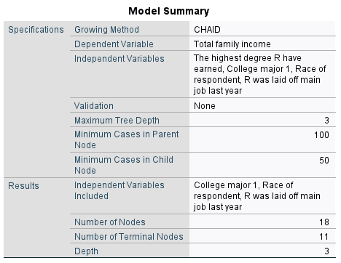

The table provides a summary of a decision tree model built using Chi-squared Automatic Interaction Detection or CHAID algorithm.
- Specifications
- The decision tree has a maximum depth of 3 levels, meaning that it only goes three levels deep in segmenting the data.
- Minimum Cases in Parent Node: 100 cases will be required for a parent node to be considered for splitting.
- Minimum Cases in Child Node: A minimum of 50 cases were required in child nodes after a split for the node to be retained.
- Results
- Independent Variables Included in the Final Model
- College Major
- Race of Respondent
- Laid Off Main Job Last Year
- Independent Variables NOT included in the final model: “The highest degree earned”, meaning this variable was not selected as a significant predictor in the final model after splitting.
- Number of Nodes: The decision tree model contains a total of 18 nodes, representing various splits and groupings of the data.
- Number of Terminal Nodes (Leaf Nodes): There are 11 terminal nodes, meaning the tree ends with 11 final groups or segments where predictions are made.
- Tree Depth: The tree has a depth of 3 levels, indicating the complexity and number of interactions considered in segmenting the data for prediction.
- Findings
- The CHAID model suggests that College Major 1, Race of Respondent, and Laid Off Main Job Last Year were significant predictors of total family income.
- After initial analysis, the variable "The highest degree earned" did not contribute significantly to the model's prediction after initial analysis, thus it was excluded from further splits.
- The decision tree reached a depth of 3 levels, which reflects a moderately complex structure for explaining variations in family income based on the included predictors.
- With 11 terminal nodes, the model groups individuals into specific categories that reflect differing predicted family incomes based on the most significant splits, offering actionable insights into income variability.
- In Summary
The model shows that education majors, race, and recent job layoffs were more influential in predicting family income, as reflected in the splits and final nodes.

- Gain Summary for Nodes
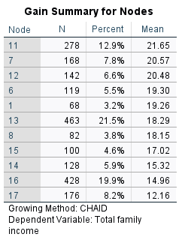
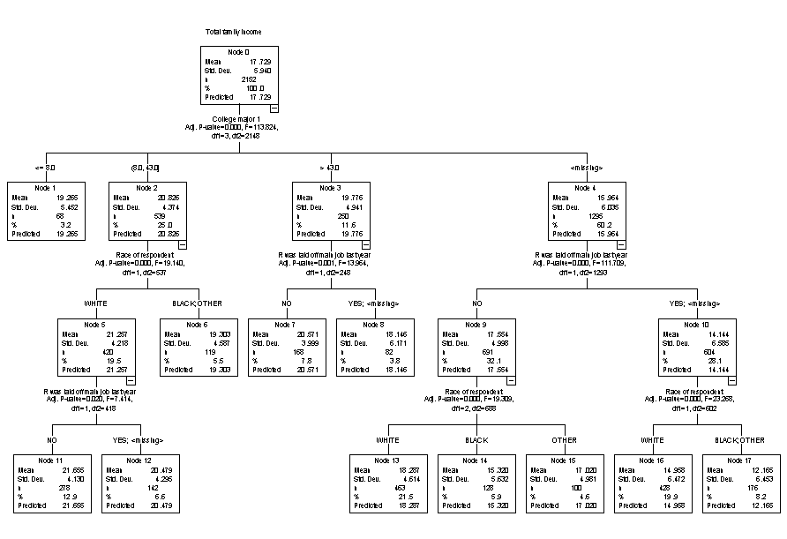

The Gain Summary table provides information on how the decision tree model splits data into nodes and the distribution of the dependent variable, Total Family Income, within each node.
Overall Tree Decision Interpretation:
- Node: Each row corresponds to a specific node in the decision tree. These nodes are formed based on the CHAID splitting criteria and represent distinct segments or groups of data.
- Number of Observations (N): This column shows the number of cases (observations) in each node. For example, Node 11 has 278 observations.
- Percent: This represents the percentage of total observations in each node relative to all observations considered in the model. For instance, 12.9% of the observations belong to Node 11.
- Mean: This is the mean value of the Total Family Income for observations in each node. It reflects the average income for that specific segment of data.

Chose Terminal Node 7 findings in detailed:
- Training Data Mean = 20.57 | Predicted Value = 21 | Standard Deviation = 3.999
- Interpretation:
- Node 7 is the one with no splits or branches below it.
- N = 168
- Percent: This node accounts for 7.8% of the total data, which translates into 168 cases fall within this specific segment.
- The mean total family income for individuals in this node is 20.57. This value indicates the average income for this particular group, which is lower than the mean for Node 11 but still relatively high compared to other segments in the decision tree.
- The standard deviation of 3.999 suggests a moderate spread of total family income values around the mean, indicating that while there is variability within this group, it is not excessive. The predicted value of 21 aligns closely with the mean of 20.57, suggesting that the model captures this segment’s characteristics reasonably well, with relatively consistent predictive power for this group.
- Compare the predicted value from the Training sample to the Actual value in the Test sample:
- Close Agreement:
- The predicted value =21 is very close to the mean value =20.5. The slightly difference indicates that the decision tree model has accurately learned the relationship between the independent variables and the dependent variable (total family income) for this segment.
- This close agreement also proves that the model represents the training data accurately for this node, without introducing biases or errors.
- No Evidence of Overfitting
Since the predicted value aligns closely with the training data mean, there is no strong indication of overfitting for this particular node when evaluated within the context of the training data. Overfitting would typically manifest as a predicted value that deviates significantly from the training data mean or does not generalize well to new (test) data.
- Overall:
- The close agreement Node 7 indicates that the model is accurately capturing the characteristics of this node based on the training data. This suggests that the decision tree is well-fitted for this segment in the training data and does not exhibit signs of overfitting for Node 7.
- Higher mean values in nodes (e.g., Node 11) suggest that this group is positively impacted by the independent variables used in the model, while lower mean values (e.g., Node 17) may indicate negative or lesser impacts.
- The distribution of mean incomes and percentages among nodes illustrates how factors such as race, work position, and college major affect income levels and draws attention to the variation in family income.

- Risk
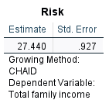

Interpretation
- Estimate: This is the measure of risk or prediction error for the model. In this case, the risk estimate is 27.440, which indicates the average deviation of the predicted total family income values from the actual values in the data. The risk estimate gives an idea of how well the model is fits he data.
- Standard Error (Std. Error): This value of 0.927 reflects the variability or uncertainty associated with the risk estimate. A smaller standard error suggests greater precision in the risk estimate.

Summary
- The model's average forecasts of total family income differ by about this much from the actual income figures, according to the Risk Estimate of 27.440. Depending on the scale of total family income used in the model, this result may imply moderate to severe inaccuracy.
- Despite some intrinsic variability, the estimate appears to be reasonably accurate, as indicated by the Standard Error of 0.927.
- In conclusion, even though the model seems to have some predictive capability, the risk estimate indicates that the predictions contain considerable errors. This suggests that the model's accuracy could be increased by incorporating more pertinent predictors, improving data processing, or employing more sophisticated modeling techniques.

- Key Conclusions
Based on the results of the decision tree model analysis, we can draw several important conclusions about the relationship between the independent variables and Total Family Income as well as the model's overall predictive capability:
- Key Predictors: The model found that the respondent's race, college major, and whether or not they were laid off from their primary job the previous year were all significant predictors of the family's overall income. It's interesting to note that the model's predictive power was not considerably impacted by the highest degree earned, suggesting that current work status, racial background, and particular majors may be more important factors in forecasting income.
- Segmentation of Data: The decision tree segmented the data into 18 nodes, with 11 terminal nodes representing distinct groups based on combinations of the predictor variables. This segmentation highlights how different groups within the data experience varying average levels of total family income, reflecting social and economic disparities or trends influenced by the predictors.
- Variation in Mean Income: The nodes with the highest average family income (e.g., Node 11) indicate which groups benefit the most, while nodes with lower means (e.g., Node 17) reflect those facing challenges in achieving higher incomes. This provides valuable insights into potential areas for policy intervention or support based on demographic or educational factors.
- Model Performance: Although the model can predict total family income, there is a noticeable error in this prediction, indicating that additional factors not included in the model may also be significant predictors of income, according to the risk estimate of 27.440 and standard error of 0.927.
- Model Limitations: The decision tree's moderate with max depth =3 represents a comparatively straightforward structure that might be suitable for comprehending general patterns but might miss some subtleties of income prediction. In the absence of cross-validation or testing on a separate dataset, the decision to omit validation suggests that caution should be exercised when assessing model performance.

Final Conclusion
The CHAID decision tree model emphasizes the importance of race, work position, and college major. According to the analysis, a number of educational, demographic, and employment-related characteristics affect total family income; the most important predictors are race, college major, and laid-off status. These variables reveal both possibilities and disadvantages through intricate interactions that impact economic outcomes. The model's capacity to account for these factors makes it a useful tool for comprehending income fluctuation and identifying particular groups for additional research or legislative actions.

