HUYNH DO
Module 8, Market 1
- Create a sequence chart to visualize the series that you’ve selected and describe any trends or seasonality you observe.
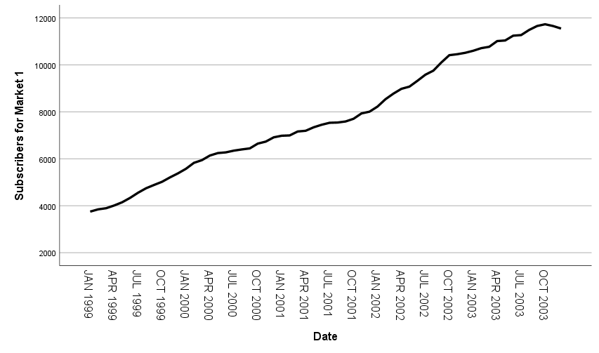
- Overall Growth Trend:
The chart exhibits an upward trend over the years, indicating overall growth in "Market 1" values.
- Seasonality:
- There appear to be some minor fluctuations within individual years, but these fluctuations are not strong.
- Growth seems to slow down towards the end along the time x-axis after 2002, where there are smaller increases and occasional dips.
- Notable Downturn:
- From early year of 2002, the chart shows a slight slowdown in number of subscribers.
- Towards the end of 2003, there is a notable drop compared to the preceding months, which marked the end of more than 4 decades of increasing number of subscribers.

- Create a second sequence chart choosing the difference option to remove the trend from the time series.
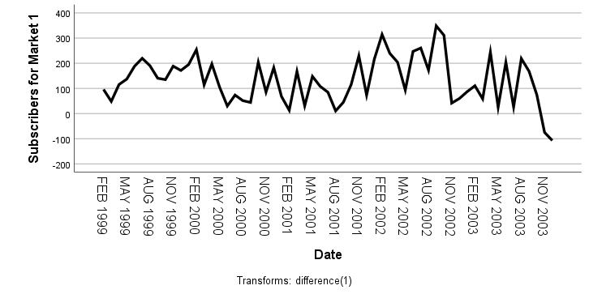

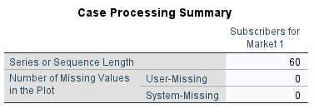
Missing Values:
- User-Missing: 0: No values are missing due to user error or manual omission.
- System-Missing: 0: The data is complete with no missing entries from system errors or incomplete datasets.

Observations from the Differenced Sequence Chart:
- Variability: The differenced series exhibits both more stable times with few changes and times with more deviations (such as abrupt increases or reductions).
- No obvious seasonality: Despite some discernible periodic peaks and troughs, the variability does not seem to follow a distinct seasonal pattern.
- Understanding Fluctuations: The graph highlights particular instances of notable expansion or contraction that were obscured by the overall pattern in the original data.

- Stand out 2002 Observations:
- Positive Fluctuation:
  - A sharp positive spike indicates a significant increase values within a short period.
  - This could be due to market expansion, seasonal demand, or an external event such as a policy change or economic boost.
- Negative Fluctuation:
- Saturation after the previous surge.
- A one-time event driving the prior spike that quickly dissipated.
- Normalization after an overreaction in the market.
- Stand out 2003 Observations:
- Negative Fluctuation:
  - Economic downturn or market contraction.
  - Seasonal or cyclical demand drop.
  - Specific disruptions, such as policy changes, regulatory interventions, or external shocks.
- Recovery: After this drop, there’s a gradual recovery, suggesting that the decline was temporary rather than a systemic failure.
- Run the expert modeler on the series that you’ve selected and interpret the results

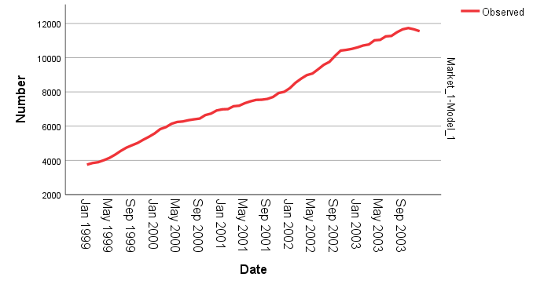

- Explain the type of model selected and it's parameters, e.g., if a Holt model is selected, explain that it is an Exponential Smoothing model and the meaning of the alpha and gamma parameters. If an ARIMA model is selected --e.g., ARIMA(1,0,1) -- explain the components.
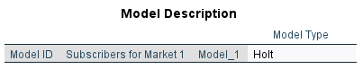

- Hold Model With Forecast
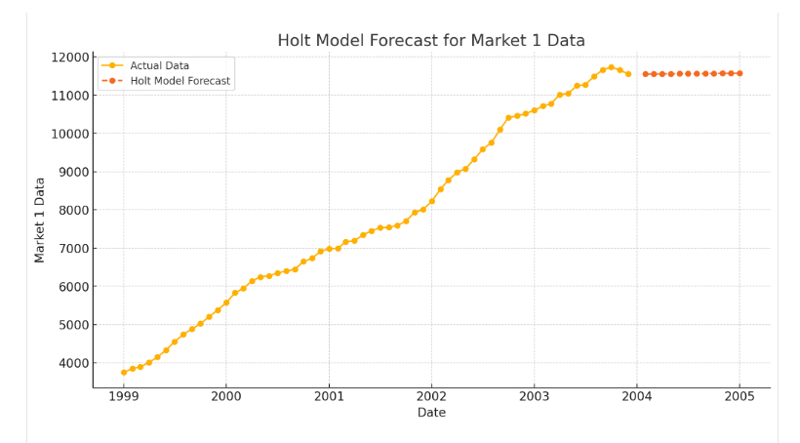
Hold Model’ Forecast
The flat-line forecast from the Holt model suggests that the model has interpreted the historical data as having no significant upward or downward trend toward the end of the series. Here's what might happens:
- Stable Trend:
    - The model's trend component has likely stabilized to a nearly constant value close to zero.
    - This happens when the historical data shows little or no consistent directional change in recent periods.
- Smoothing Over Variability:
    - If the historical data contains short-term fluctuations but no pronounced trend, the Holt model will average these out, resulting in a nearly flat forecast.
- Possibility of Data Saturation:
    - A flat forecast might also indicate that the data is approaching a saturation point (e.g., market maturity or a plateau in subscriber growth).
- No Seasonality:
    - Since Holt's model doesn't account for seasonality, any repeating patterns in the data (if present) will not influence the forecast.

Parameters of Holt's Model:
- Alpha (Level Smoothing Parameter):
  - Controls the rate at which the influence of older observations diminishes.
  - A high alpha (closer to 1) gives more weight to recent observations, making the model more sensitive to short-term fluctuations.
  - A low alpha (closer to 0) smooths the data more heavily, emphasizing long-term trends over recent changes.
- Beta (Trend Smoothing Parameter):
  - Determines how quickly the model reacts to changes in the trend.
  - A high beta (closer to 1) makes the trend component highly sensitive to recent changes.
  - A low beta (closer to 0) smooths out short-term variations in the trend.
Hold Model Parameters
Time series forecasting technique for modeling data with trends is the Holt Model. By including a component for the trend, it goes beyond basic exponential smoothing. Because of this, it works well with time series data that exhibits a trend but lacks seasonality.

By applying the Holt model to the data:
- Alpha: Balances between smooth long-term trends and short-term variations.
- Gamma: Captures the direction and pace of the growth or decline in subscriptions.

- Interpret the Stationery R-squared, Mean Absolute Percent Error (MAPE), and Maximum Absolute Percent Error
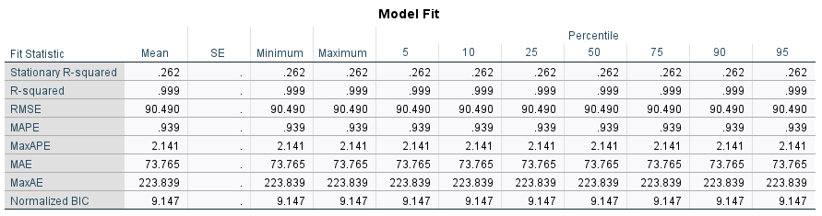
Model Fit:
- Stationary R-squared: 0.262
- The value of 0.262 indicates the model explains 26.2% of the variance in the detrended series. This is moderate but suggests room for improvement.
- R-squared: 0.999
- The value of 0.999 indicates an excellent fit, meaning the model captures nearly all of the variance in the data.
- MAPE (Mean Absolute Percentage Error): 0.939%
- The MAPE = 0.939% indicates excellent predictive accuracy, with less than 1% average error.
- MaxAPE (Maximum Absolute Percentage Error): 2.141%
- The worst-case prediction error is just 2.141%, demonstrating high reliability.

- Assess the test assumption of no autocorrelation by interpreting the residual PACF plot.
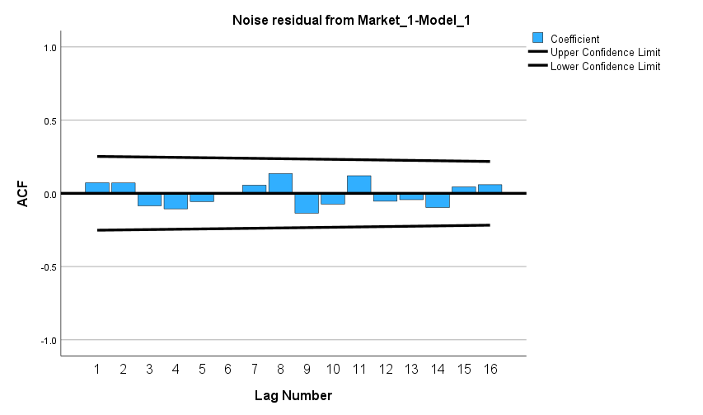

Interpretation of the PACF Plot for Residuals:

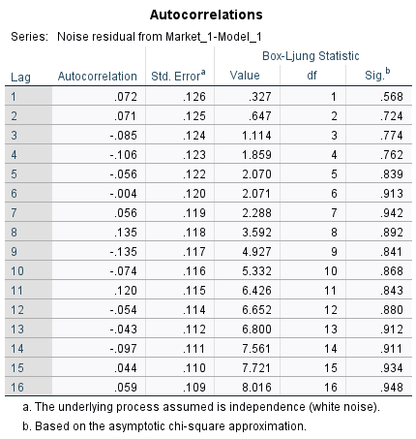

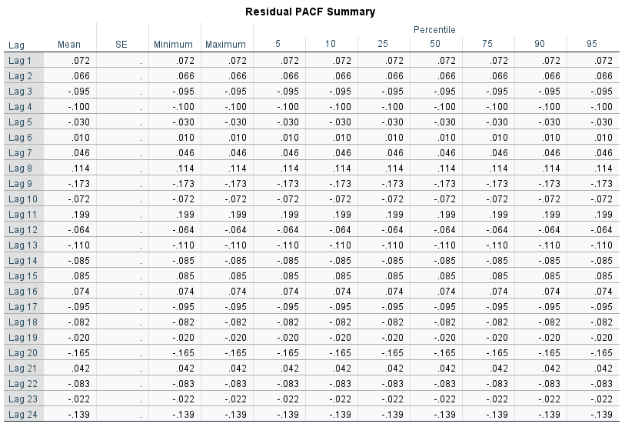

Key Lag Observations:
- Lag 1 and 2: Both are small positive values (0.072 and 0.066), suggesting a weak but positive partial autocorrelation.
- Lag 8: Displays a moderately positive PACF value (0.114), which might be worth investigating for cyclical behavior.
- Lag 11: This stands out with the highest PACF value (0.199), indicating a stronger partial autocorrelation at this lag.
- Lag 9 and Lag 20: These have notably negative PACF values (-0.173 and -0.165), suggesting some inverse relationships at these lags.
- Overall Trend: There are alternating signs with generally small values, indicating no dominant autocorrelation across lags but with a few notable peaks (like at lag 11).

PACF Observations:
- Box-Ljung Significance (p-values):
- The Box-Ljung test evaluates whether residuals are independently distributed.
- Sig. b are greater than 0.05 (ranging from 0.568 to 0.948), indicating no significant autocorrelation at any lag.
- Confidence Interval:
  - The red dashed lines represent the 95% confidence interval. Any partial autocorrelation outside these bounds indicates significant autocorrelation at the corresponding lag.
- Significant Lags:
  - Lag 9 and Lag 11 exhibit significant spikes, as their values fall outside the confidence interval. These suggest some degree of autocorrelation that the model has not captured at these lags.
  - Most other lags are within the bounds, indicating no significant autocorrelation.
- No Systematic Pattern:
  - There is no consistent pattern in the residuals, such as a gradual decay or cyclical behavior, which suggests that the model has largely addressed the trend and autocorrelation in the data.
- Conclusion:
  - The residuals are mostly white noise, but the significant spikes at Lag 9 and Lag 11 indicate minor unexplained structure in the data.
  - The PACF and Box-Ljung test collectively support the assumption of no autocorrelation in the residuals. This indicates that the model effectively captures the underlying structure of the time series, leaving no significant patterns or dependencies in the residuals.
- Using a sequence chart, visually display the results of the time series model and explain your findings. Plot the actual values, Predicted Values, and Confidence Intervals around the Predicted Values.

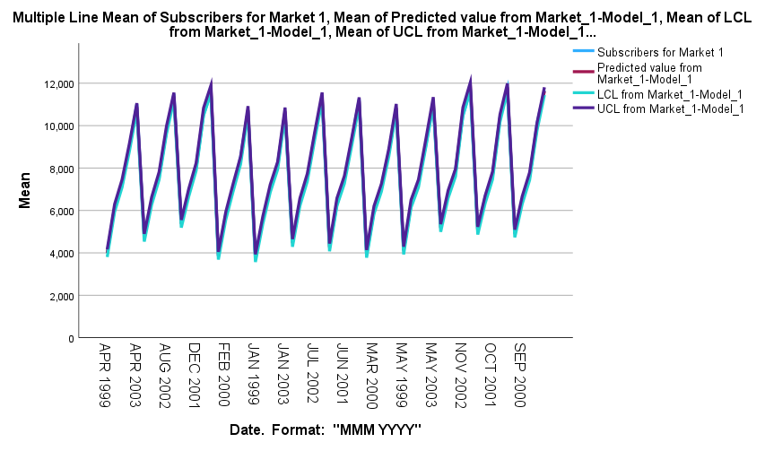
- Key Observations:

- Repeating Growth
- The data starts at 4000 and rises over the first 3 consecutive years, indicating an upward trend in values, potentially due to market expansion, new products, and increased subscriptions.
- However, after the year of 2003, the number of subscribers show signed of improvements by staring at 5000 toward the end of the Seri.
- Repeating Sharp Decline
- After peaking at 12000 subscribes, the number of subscribers drops back down to a little bit over 4000 over the next two years, suggesting a reversal of growth due to market saturation, competition.
- High Variability
- The number of subscribers oscillated around the base line 8000 and in the range of 4000 and 12000 suggests that the system or market being studied is highly fluctuated possibly other competitors came online.

- Predicted Value, Upper Confidence, Lower Confidence, and Actual Value lines are almost overlapping:
- Very Closed Confidence Intervals:
  - Visually, the upper and lower confidence interval lines are very close to the predicted value line, it suggests:
    - The model is highly confident in its predictions.
    - The variance in the data is small, resulting in narrow confidence intervals.
- Actual Values Agreed with Predictions:
  - The actual values are closely following the predicted line, the model is effectively capturing the underlying trends and patterns in the data.
  - Low Residuals:
  - Minimal deviation between actual and predicted values shows low residuals, indicating a well-fitting model.

