HUYNH DO
Module 8, Market 2
Choose at least two series from the broadband to perform Time Series and complete the following prompts:
- Create a sequence chart to visualize the series that you’ve selected and describe any trends or seasonality you observe.

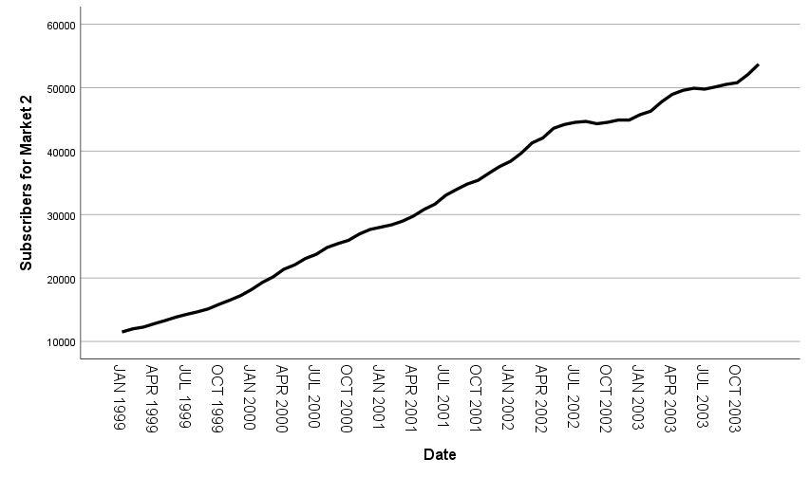

Observations:
- Trend: The data shows a general upward trend from 1999 to 2001, indicating growth in market value over this period.
- Plateau and Variability: The market faces increasing volatility, including periods of standstill and slight falls, as the expansion slows around the middle of 2001.
- Recovery: From late 2002 to 2003, the market resumes an upward trend, ending at a higher number of subscribers.

Seasonality:
There is no clear seasonal pattern in this dataset, as the fluctuations seem irregular and not tied to specific intervals or time of the year.
- Create a second sequence chart choosing the difference option to remove the trend from the time series.
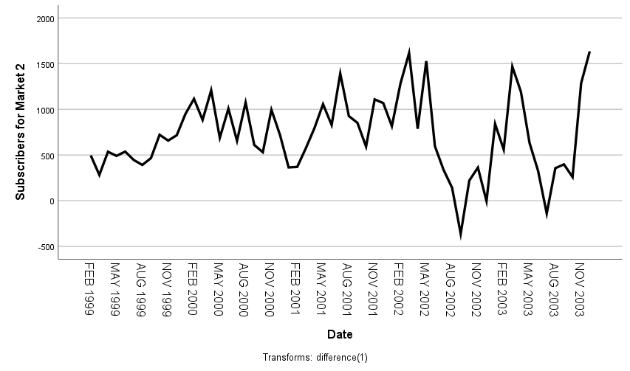

Observations from the Differenced Sequence Chart:
This differenced approach is useful for analyzing the underlying behavior of the series without the influence of long-term trends.
- Variability: The differenced values highlight periods of high variability, with noticeable spikes in both positive and negative directions.
- No Clear Pattern: The differenced series does not display a consistent pattern or seasonality, suggesting irregular fluctuations in market value.
- Volatility Clusters: There are periods where changes are relatively stable, followed by periods of heightened volatility, particularly around 2001-2002.

- Run the expert modeler on the series that you’ve selected and interpret the results

- Explain the type of model selected and it's parameters, e.g., if a Holt model is selected, explain that it is an Exponential Smoothing model and the meaning of the alpha and gamma parameters. If an ARIMA model is selected --e.g., ARIMA(1,0,1) -- explain the components.

- Hold Model With Forecast
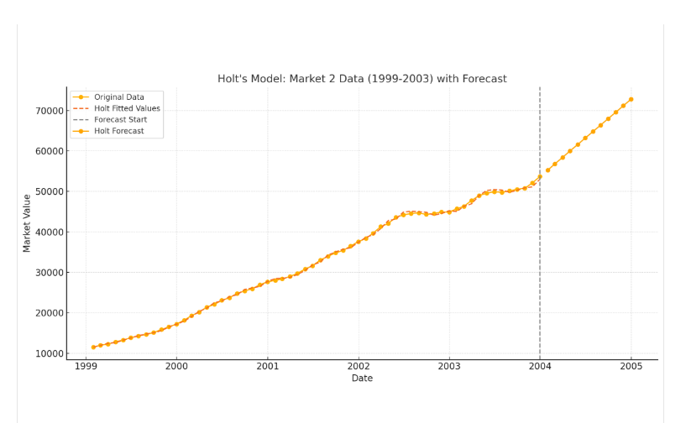
The chart demonstrates the application of Holt's model on the data, showing:
- Original Data: The observed values from January 1999 to December 2003.
- Holt Fitted Values: The model's fitted values, which closely follow the original data's trend.
- Forecast: A 12-month projection beyond December 2003, indicating a continuation of the upward trend.

Forecasted Values:
- January 2004: 55,222
- February 2004: 56,817
- March 2004: 58,412
- April 2004: 60,007
- Hold Model Parameters
- Alpha (α): The smoothing parameter for the level.
  - Controls how much weight is given to the most recent observation relative to the past data.
  - Ranges between 0 and 1:
  - Low α: Smoother series but slower adaptation to changes.
  - High α: Reacts quickly to changes but may capture too much noise.
- Gamma (γ): The smoothing parameter for the trend.
  - Controls how much weight is given to the trend component over time.
  - Ranges between 0 and 1:
  - Low γ: A more stable trend estimate.
  - High γ: A trend estimate that adapts quickly to changes.

- Interpret the Stationery R-squared, Mean Absolute Percent Error (MAPE), and Maximum Absolute Percent Error
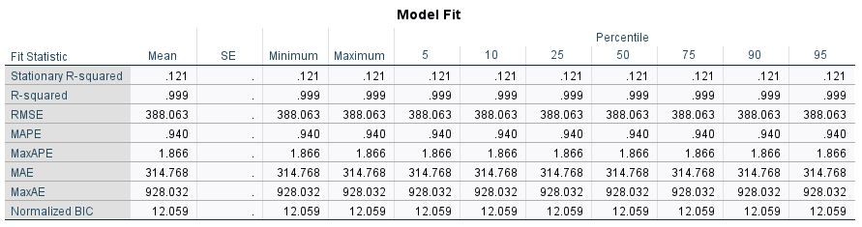

Model Fit:
- Stationary R-squared (0.121):
- Measures how well the model explains the variance in a stationary version of the data (adjusted for trend/seasonality).
- A value of 0.121 suggests the model has limited explanatory power for the stationary data.
- R-squared (0.999):
- Indicates the proportion of variance explained by the model for the original data (not stationary-transformed).
- A near-perfect score (0.999) implies the model fits the original data exceptionally well.
- MAPE (0.940):
- Mean Absolute Percent Error represents the average percentage error between actual and predicted values.
- At less than 1% (0.940), the model demonstrates excellent accuracy.
- MaxAPE (1.866):
- Maximum Absolute Percent Error is the largest percentage error in the dataset.
- The maximum error of 1.866% indicates the model performs well across all observations.

Implications:
- The model fits the original data exceptionally well (R-squared = 0.999) but struggles with explaining stationary variations (Stationary R-squared = 0.121).
- The forecast errors are minimal, as evidenced by low MAPE (0.940%) and MaxAPE (1.866%).
- High MaxAE (928.032) could indicate occasional outlier deviations, possibly requiring further exploration.
- Assess the test assumption of no autocorrelation by interpreting the residual PACF plot.

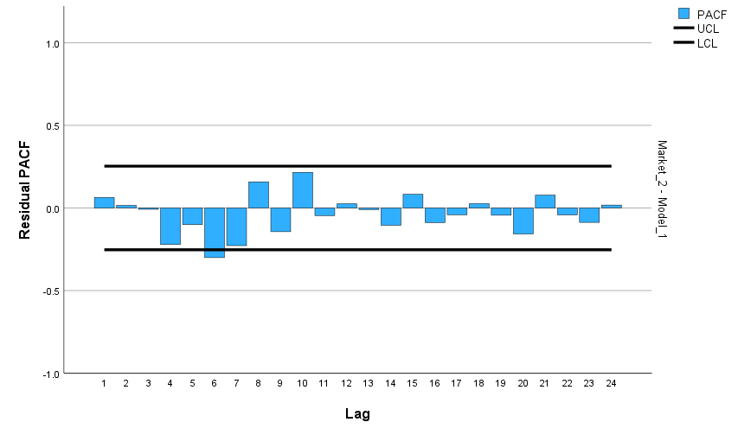
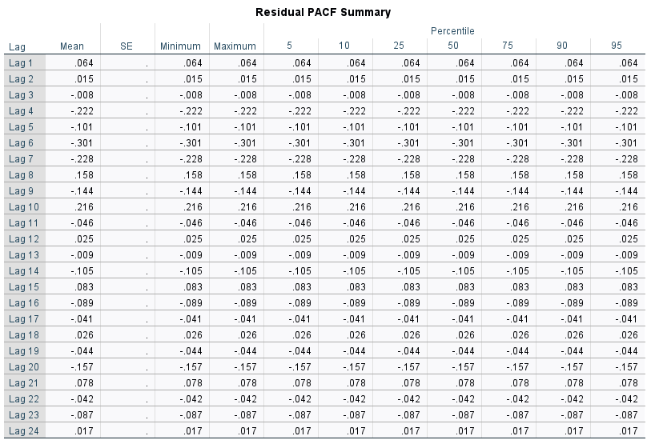

Key Observations from Residual PACF
- Lag 1 (0.064):
  - A small positive correlation exists at lag 1, suggesting minimal short-term dependency in residuals.
- Lag 2 (0.015):
  - Almost no correlation at lag 2, indicating little to no dependence between values two steps apart.
- Lags 3 to 6:
  - Lag 4 (-0.222) and Lag 6 (-0.301) show stronger negative correlations, suggesting potential systematic error patterns that may require further investigation.
  - These spikes might indicate model underfitting or residual autocorrelation.
- Lag 7 to 12:
  - Most lags show weak correlations, but Lag 8 (0.158) and Lag 10 (0.216) are moderately positive.
  - Residual patterns around these lags suggest some short-term relationships remain unexplained.
- Lags 13 to 24:
  - Weak correlations dominate, with values near zero, indicating no significant long-term autocorrelation in residuals.

Interpreting the Residual PACF
- Pattern:
Ideally, residuals should resemble white noise, meaning most lags should have near-zero PACF values within the confidence interval (approximately ±1.96/√N for a 95% level).
  - Significant spikes at lags (e.g., Lag 4 and Lag 6) may indicate model inadequacy.
  - This could signal the need for additional predictors or adjustments (e.g., increasing lag terms in an ARIMA model).
- Using a sequence chart, visually display the results of the time series model and explain your findings. Plot the actual values, Predicted Values, and Confidence Intervals around the Predicted Values.

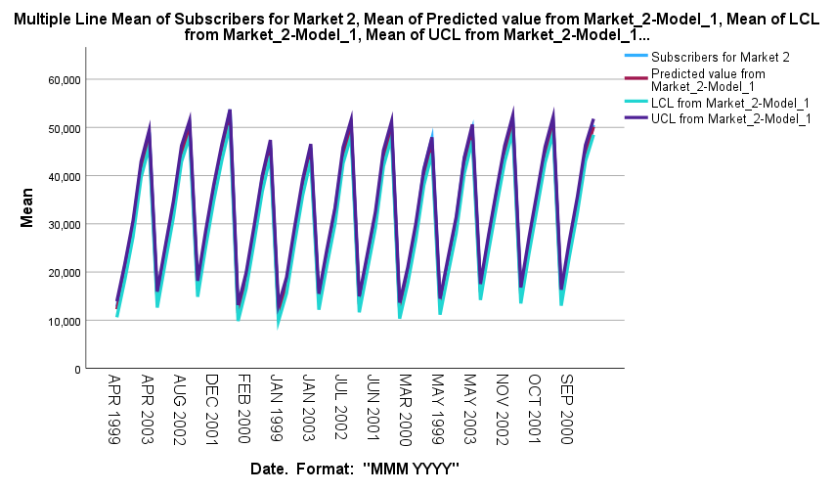

- Key Observations:
- Repeating Growth and Decline:
    - Indicates a cyclical or seasonal pattern in the data.
    - The cycles may not have been explicitly modeled, causing the predicted values to follow the observed pattern too closely.
- Overlapping Lines:
  - Suggests the model fits the data very well (low residuals) but might not account for any uncertainty or future variations (overfitting or lack of flexibility).
  - Confidence intervals are too narrow, implying the model is overly confident about predictions.
- Predicted Value, Upper Confidence, Lower Confidence, and Actual Value lines are almost overlapping:
- Very Closed Confidence Intervals:
  - Visually, the upper and lower confidence interval lines are very close to the predicted value line, it suggests:
    - The model is highly confident in its predictions.
    - The variance in the data is small, resulting in narrow confidence intervals.
- Lower Confidence Limit (LCL) line is slightly lower than the other lines (Actual, Predicted, Upper Confidence Limit)
- Narrow Confidence Intervals
The confidence intervals (LCL and UCL) are very close to the predicted line.
This suggests that the model is confident in its predictions, with low residual variability.
- Asymmetric Variability
If the LCL is systematically lower, the model may expect greater downside risk (e.g., steeper declines) compared to upward trends.
- Bias in Residuals
If the residuals are not evenly distributed (e.g., negatively skewed), the LCL may drift lower compared to the UCL.
- Overfitting or Misspecification
If the model fits the data too closely (overfitting), it can fail to reflect realistic variability, leading to narrow or biased confidence intervals.

- Actual Values Agreed with Predictions:
  - The actual values are closely following the predicted line, the model is effectively capturing the underlying trends and patterns in the data.
  - Low Residuals:

